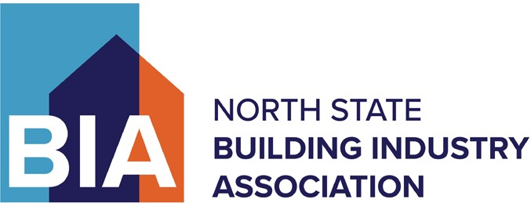

We recorded several major accomplishments during the first half of 2023 and are proud to share them with you. Thank you for your continued support of the BIA!

Government and Public Affairs
The Government and Public Affairs Department works on behalf of the industry by advocating for public policies that foster a healthy building climate to ensure that well-planned communities continue growing to meet the region’s housing needs. Here are some of the staff’s top accomplishments during the first half of 2023.

- PG&E CEO Meeting and Technical Committee
BIA hosted a meeting with CEO Patti Poppe in which she committed to improving customer service through an examination of their process from application to energization and setting ambitious customer on time delivery goals. Several potential improvements have already been identified, including the possibility for developer tie-ins and scheduling enhancements.

- Sac County Passes Major Reform Resolution
The Sac County Board of Supervisors unanimously passed an official resolution affirming the board’s intent to reform the development review process with new cultural changes and accountability. The County is now hiring development process managers and creating more flexible standards in many areas.

- Lincoln PFE Improvements
Cut thousands of dollars in increases in 2023-24 by identifying issues and inconsistencies with the Public Facilities Element passed last year.

- Placer and Sac County Process Improvement Groups
BIA staff helped develop working groups in both Placer and Sacramento to allow our industry to partner with the counties toward improving the development process, focusing on entitlements & environmental issues as well as improvement plans & construction issues.

- Preventing Higher Fees
- City of Sacramento delaying its Utilities Fee until BIA completes its evaluation.
- BIA is working with SASD on potentially problematic areas of its new connection charge.

- Cap to Cap
BIA staff took regional leadership roles on transportation and landed us on the federal Cap to Cap lobbying trip. Local BIA staff has helped forge stronger relationships with members of Congress and federal agency staffs.

- Elk Grove Creates Working Group in Response to BIA Concerns
After hearing from several BIA members and BIA staff consistently, and after the BIA expressed concerns to City Councilmembers, city staff agreed to form a new committee to analyze and refine city policies increasing construction times. The newly formed committee is going over industry concerns ranging from overly burdensome design standards to the way city staff interacts throughout the process.

- FCUSD to Discuss Use of Value Engineering at BIA Request
At the BIA’s request, the school district announced that it would consider options for incorporating value engineering.

Member Services
The Member Services Department focuses on building membership to ensure it is as representative of the region’s homebuilding industry as possible. Member Services also coordinates numerous targeted networking and industry education events throughout the year. Key accomplishments include:

- Membership has increased 1% since the beginning of the year from 520 to 525.

- Launched @NorthStateBIA on Instagram.

- Successful partnership with Sacramento Realtors Association on Builders Showcase event with over 200 realtors and 14 builder companies’ participation.

- Events continue to be popular with record attendance at all events.

- Kicked off young professionals group called BRIDGE – Building Relationships in Development Growth Empowerment

- The enhanced traffic reporting database went live, which gives participants the ability to access the data stored in the system and create custom reports with more detail.

- Educational workshops have increased with a variety of topics, such as SB800, sales agent training, jobsite safety, OSHA, and more.

HomeAid Sacramento
Since 1996, HomeAid Sacramento – one of the BIA’s two affiliated charities – has been involved in constructing transitional housing facilities that serve, temporarily or transitionally, homeless families and individuals. Accomplishments include:

- The first phase of an existing HomeAid Builds development project is complete and ground has been broken on the second phase (VOA Bell Street Veteran’s Apartments), with clearance to break ground on our Maryhouse Bath Remodel project. This is in addition to the planning stages of three other new development projects.

- HomeAid Sacramento has successfully completed over a dozen HomeAid Cares projects providing residents with valuable supplies and other service needs.

- HomeAid Sacramento had major media presence in the first half of 2023. A few notable highlights were participation in a ULI Program Panel Discussion on the topic of homelessness in Sacramento; Featured in the March edition of Builder and Developer magazine and various other local El Dorado County news articles, plus a return to KTXL FOX40 News Studio Live 40. Also, HomeAid Sacramento proudly accepted the 2022-2023 SMUD Shine Award, many thanks to the Sacramento Municipal Utilities District, for the acknowledgment of the VOA laundry/community room as their Energy Efficiency award.

North State Building Industry Foundation
The Foundation, the BIA’s other affiliated charity, develops community projects and raises funds to support educational, community, and research projects. Its core mission is to provide workforce development services for existing workers and people entering the industry. Accomplishments during the first half of 2023 include:

- The North State Building Industry Foundation continues growing in 2023. The first half of the year provided training for approximately 150 individuals through community college programs, Out of School Youth, Summer Internships, Pathways to Yes, Harbor Freight Fellowships, Externships and more.

- Began recruitment for HBI’s BuildStrong Academy, Rancho Cordova’s Building Tomorrow’s Workforce Today program, and spoke with additional school districts about expanding our current high school programming with both El Dorado County and Elk Grove expressing interest in our programs.

- Project My Own Bed did a delivery to two families in connection with the Family Justice Center. Other requests have come in and we are currently focusing on building funds to sustain the program.

- This year’s Skilled Trades Job Fair had 50 students and 17 employers, of which, the quality of attendees was fantastic, and several employers shared that they walked away with leads or were able to hire on the spot.

- The Foundation received press coverage in the Sacramento Business Journal, mentioned in an article with the BIA for the Sacramento Bee, live interview on Studio 40 (relating to the Bank of America grant), and recently did a podcast on Associations Thrive talking about the work the Foundation does in building talent for the future.

