FOR IMMEDIATE RELEASE December 29, 2020

Contact: Ingrid Klinkhart
Cell: (907) 230-0415
Email: ingridk@goyuit.com

Diverse Coalition Launches Effort to Help Get Alaskans Across the COVID Finish Line

Anchorage, Alaska – A coalition of business, healthcare and Alaska Native organizations launched a statewide campaign today to inspire Alaskans to stay healthy, get vaccinated and work together to overcome this pandemic. The Conquer COVID Coalition is a nonprofit effort that encourages Alaskans to follow safety measures so we can fully reopen the state’s economy. Experts believe it will take several months before the vaccine is widely distributed and the coalition will focus on making sure Alaskans remain COVID-responsible during that time.

"We don’t want Alaskans to let down their guard when we’re closing in on beating this pandemic,” said Jared Kosin, Conquer COVID Coalition co-chair and president and CEO of the Alaska State Hospital and Nursing Home Association. "Public awareness is the key to getting across the finish line. This coalition will work side-by-side with the State of Alaska and local governments to help ensure we conquer COVID."

The coalition’s mission is to educate Alaskans about specific steps they can take to stop the community spread of COVID-19 and to achieve a sustained level of control that allows individuals, families and communities to return to a fully functioning society and economy. Conquer COVID Coalition’s educational campaign will target rural and urban communities through a variety of platforms. Its website also provides free COVID safety tools that businesses and organizations can download, such as posters, flyers, social media graphics, and animations.

“The most successful campaigns have involved diverse groups coming together to work towards a common goal,” said GCI Chief Communications Officer Heather Handyside and coalition co-chair.
“This is about Alaskans helping Alaskans and it’s never been more critical.”

“Healthy people drive a healthy economy,” said Kati Capozzi, Alaska Chamber president and CEO
and coalition co-chair. “Right now Alaskans and our businesses are suffering. If we want to fully reopen restaurants and retail and have a tourism season, we must follow COVID safety guidelines, stay healthy and get vaccinated.”

Conquer COVID Coalition Co-Chairs:
Preston Simmons, DSc, FACHE – Chief Executive, Providence Health & Services Alaska
Jennifer Opsut – COO & Interim CEO, Alaska Regional Hospital
Heather Handyside – Chief Communications Officer, GCI
Gail Schubert - President & CEO, Bering Straits Native Corporation
Sophie Minich – President & CEO, CIRI
Heidi Heinrich - Owner, Lucky Wishbone Restaurant

Jared Kosin - President & CEO, Alaska State Hospital and Nursing Home Association
Cheri Gillian - Executive Vice President & Chief Administrative Officer First National Bank Alaska
Bill Popp - President & CEO, Anchorage Economic Development Corporation
Kati Capozzi - President & CEO, Alaska Chamber

Our Members include:
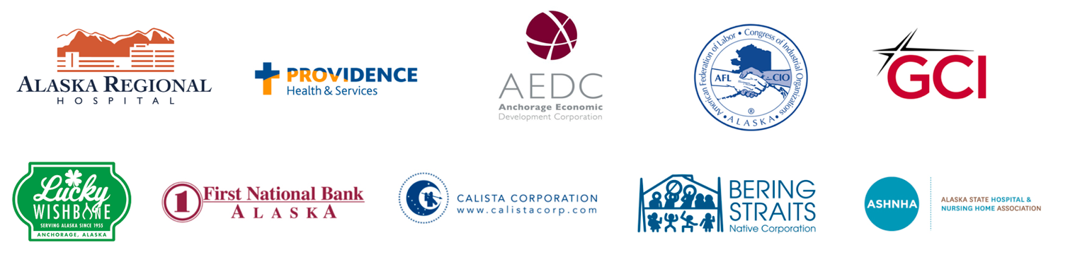

Learn more: www.ConquerCovidAK.com

###

