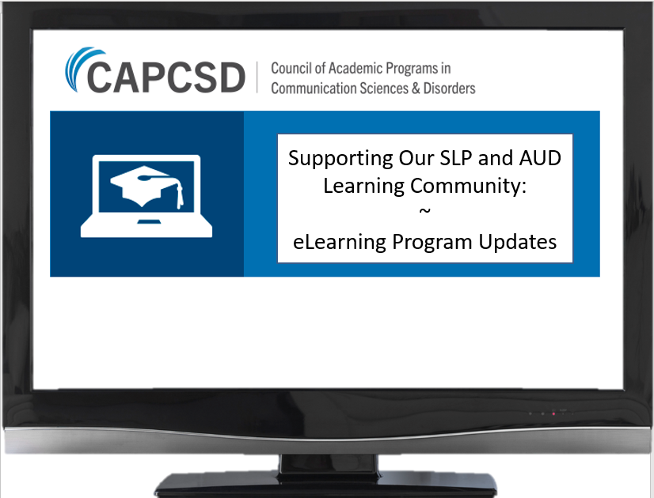
No-Cost Continuing Education Opportunities!
eLearning courses are now available to University of XXXXX Clinical Instructors through the Council for Academic Programs in Communication Science & Disorders (CAPCSD). There are FIVE modules in each course. Each module offers 2-4 hours of approved continuing education for ASHA and AAA. For details and access information CLICK HERE! or contact XXXXX



