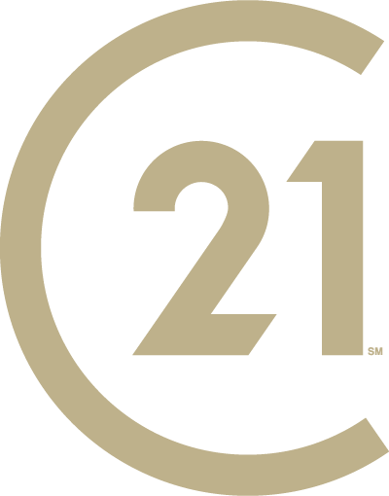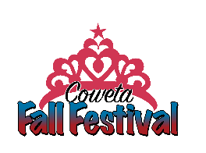
2022 Miss Fall Festival Pageant
Applicant Packet
Email: fallfestivalpageants@gmail.com

Please join us for orientation on Tuesday, Aug. 30 at
7:30 p.m. at Coweta City Hall.
During this session, we will take group photos for pageant promotions.
Please dress appropriately.
This is a mandatory meeting.
This year’s pageant will be held Thursday, Sept.15.
We look forward to working with you as you participate in the
2022 Miss Fall Festival pageant!

Application Rules and Deadlines:
- Pageant is limited to the first 12 applicants.
- Completed applications must be turned in at the Coweta Chamber office at
115 S. Broadway by Monday, Aug. 29.
- Emailed applications will NOT be accepted
- Applications will not be considered complete until the $10.00 entry fee is paid.
- Each contestant must turn in a color headshot photo (no larger than a 4x6) at the chamber office by August 29. Please put the contestant’s name on the back.
(This does not have to be a professional photo.)
- If photo is not received by the deadline, the contestant will not receive a score in the photogenic category.
- No changes can be made to their talent (types, song changes, etc.) after September 3.
- Any changes to talent must be emailed to: fallfestivalpageants@gmail.com

RULES & REGULATIONS
MISS FALL FESTIVAL SCHOLARSHIP PAGEANT
EACH CONTESTANT MUST:
- Be a female resident of Coweta or attend Coweta Public Schools and between the of ages 13 – 18 (must not have graduated from high school).

- Be at least 13 years of age on/or before the date of the pageant, but not over 18 years of age.

- Be single & never have been married. If contestant gets married after entering the pageant or during her reign, she must withdraw as a contestant or voluntarily forfeit her title, crown, sash, and all unused awards & scholarships. The first runner-up will be asked to assume the title for the remaining reign & must also conform to these rules.

- A current headshot or close-up photograph must be submitted with the completed application.

- Have no children & must not be pregnant. If contestant becomes pregnant after entering the pageant or during her reign, she must withdraw as a contestant or voluntarily forfeit her title, crown, sash, and all unused awards & scholarships. The first runner-up will be asked to assume the title for the remaining reign & must also conform to these rules.

- Not be a previous winner of the title of Miss Fall Festival.

- Provide her own transportation to and from all activities and events.

- Be able to attend all activities & events during her reign as Miss Fall Festival.

- Have at least a 2.75 overall grade point average.

- Have no criminal convictions against her.

- Not have engaged in any activity which, by community standards, could be characterized dishonest, immoral, immodest, indecent, or in bad taste. This does include social media postings on main or “spam” accounts. You are an example to your peers from the day you take your crown to the day you take it off, please act accordingly.

- Make every effort to attend all activities sponsored by the Coweta Chamber of Commerce. A minimum participation of 50% is required. Attendance will be checked quarterly and if attendance is below 50%, she will be asked to voluntarily forfeit her title, crown, sash, and all unused awards & scholarships. The first runner-up will be asked to assume the title for the remaining reign & must also conform to the attendance requirements.

- Agree to wear dressy casual attire when representing the Coweta Chamber of Commerce. Jeans with holes or rips are not appropriate, spaghetti straps and crop tops are prohibited and dresses/skirts must be an appropriate length.

- Any scholarship monies won will be paid out after pageant reign. The winner will have until December 31 of their graduation year to collect scholarship funds.

- Talent competition may not include any items such as live animals, weapons such as firearms, crossbows, pyrotechnics, or objects deemed dangerous.
- Once People’s Choice monies are turned in to the Miss Fall Festival Pageants, they will not be refunded or returned.

I HAVE READ AND I UNDERSTAND THE RULES AND REGULATIONS CITED ABOVE.SHOULD I AGREE TO SUBMIT MY RESIGNATION AS MISS FALL FESTIVAL OR BECOME UNWILLING TO OR UNABLE TO COMPLY WITH THE ABOVE RULES AND REGULATIONS, I WILL RETURN THE CROWN, SASH, AND ANY UNUSED SCHOLARSHIPS AND PRIZES AND WILL HOLD THE PAGEANT, COMMITTEE, AND COWETA CHAMBER OF COMMERCE MEMBERS AND EXECUTIVES HARMLESS FROM ANY LIABILITY WHICH MAY ARISE FROM MY FAILURE TO COMPLY WITH THESE RULES AND REGULATIONS.

_________________________ _________________________________________________
Date Signature of Contestant
_________________________________________________
Parent or Guardian Signature

MISS FALL FESTIVAL PAGEANT APPLICATION

Date_________________________________

Name_______________________________ Age______ Phone Number__________________________

Mailing Address____________________________________________________________________________

Email Address_____________________________________________________________________________

Parent(s) or Guardian(s) Name(s) _______________________________________________________________

Parent or Guardian Phone Numbers______________________________________________________________

School Attending__________________________________________ Grade in School__________________

Overall Grade Point Average____________________

Signature of school official verifying GPA_________________________________________________________

Talent (singing, dancing, reading, dramatic interpretation, etc. – PLEASE PROVIDE NAME OF SONG ALSO!!!)
__________________________________________________________________________________________________________________________________________________________________________________

Favorite school subjects:
__________________________________________________________________________________________________________________________________________________________________________________

Career plans & goals:
_________________________________________________________________________________________
__________________________________________________________________________________________________________________________________________________________________________________

Organizations you belong to:
____________________________________________________________________________________________________________________________________________________________________________________________________________________________________________________________________________________________________________________________________________________________________________________________

Elective offices you hold or have held:
_____________________________________________________________________________________________________________________________________________________________________________________________________________________________________________________________________________________________

Past achievements:
____________________________________________________________________________________________________________________________________________________________________________________________________________________________________________________________________________________________________________________________________________________________________________________________

Hobbies, special interests, or activities”
_____________________________________________________________________________________________________________________________________________________________________________________________________________________________________________________________________________________________

Special Interests or Causes you support:
_______________________________________________________________________________________________
_______________________________________________________________________________________________
_______________________________________________________________________________________________

Favorite Movie_________________________ Favorite Book_________________________

Favorite Song__________________________ Favorite Food_________________________

Signature of Parent or Guardian _________________________________________________________________

Signature of Contestant_______________________________________________________________________

2021 Miss Fall Festival
Scholarship Pageant

Important Dates and contact information to remember…

- Applications and a $10 entry fee are due by Monday, Aug. 29.

- Orientation/Group Photos will be Tuesday, Aug. 30 at 7:30 p.m. at Coweta City Hall. Attendance to this meeting is MANDATORY. Please come dressed and ready to be photographed.

- Talent can be no longer than 2 minutes

- Music must be on a flash drive and is due by Friday, Sept. 9, at the Coweta Chamber office. Please make sure it is labeled with your name and contestant number.

- The pageant will be held Thursday, Sept. 15 at 8 p.m.

- Rehearsals will be held Wednesday, Sept. 14 at 7:30 p.m. at the stage downtown on Broadway and Sycamore. Please bring all props at this time. Be prepared to leave them at the chamber office.

- People’s Choice decorated buckets and monies will be due on the day of rehearsals.

- If you have any questions, please email fallfestivalpageants@gmail.com

(Please keep this for reference)

