New Resource Available for Oregon Restaurants

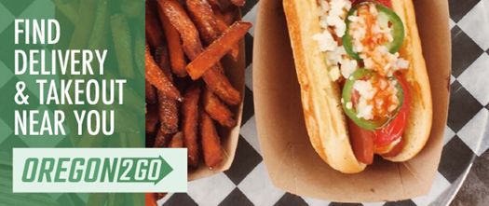

A new resource has been created to help Oregonians find restaurants, food carts, cafes, wineries, breweries, and more that are providing takeout, delivery, and curb-side options - Oregon2Go.com. The site is a partnership between Oregon Restaurant & Lodging Association (ORLA), The Oregonian, Travel Oregon and
Oregon Destination Association.

Help support these businesses by placing to-go orders or purchasing gift cards to use at a later date. Learn more about this effort.

Restaurants who would like to be added to the website can fill out the online form.

