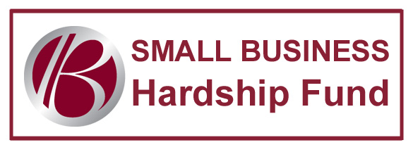
APPLICATION

COMPANY: Click here to enter text. CONTACT: Click here to enter text.
ADDRESS: Click here to enter text.
PHONE: Click here to enter text. EMAIL: Click here to enter text.

We are submitting: ☐ Phone Bill ☐ Utility Bill

INSTRUCTIONS
- Fill out form and submit with copy of recent phone or utility bill.

- All applications must be submitted electronically to ehogan@bethlehemchamber.com.

- You will receive a confirmation email confirming receipt of your application.

- Only complete application packets (application and copy of bill) will be considered.

- To be eligible, the business must be located within the Town of Bethlehem, NY or must be a Chamber member.

- When the fund is depleted, grants will cease and we will announce the end of the initiative.

Grant money is to be used for phone or utility bills only. By typing your name below you acknowledge this and agree to use the money for your business phone or utility bill.
NAME: Click here to enter text. DATE: Click here to enter text.

The Small Business Hardship Fund will award grants on a first come, first served basis. Grants will be awarded up to $200 per business. When the fund is depleted, grants will cease and we will announce the end of the initiative.

