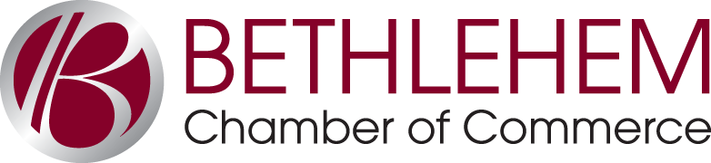

AUTOMATIC PAYMENT AUTHORIZATION

A FREE SERVICE for Guilderland Chamber members
PAY YOUR CHAMBER INSURANCE INVOICE AUTOMATICALLY… With automatic checking account deduction
Automatically pay your Chamber insurance bill(s) on a monthly basis at no additional charge with a monthly deduction from your checking account. Authorize us to automatically deduct the monthly amount on the first (1st) of each month. You’ll see the deduction on your bank statement just like a check (your own bank may assess a small ACH fee.) If the funds in your account are not sufficient to cover your monthly payment, you will be assessed a $30 insufficient funds fee.
- By signing below, I authorize the Bethlehem Chamber of Commerce to collect insurance premiums from my checking account on the 1st of each month. (i.e.: Feb 1 for February premium)
- I agree that the amount shown below is the annual membership or monthly premium amount. I understand that the deduction amount is subject to change when rates change, or if there are adjustments in insurance coverage. (ex. add/remove dependents)
- I understand that if there are insufficient funds at the time of payment resulting in a returned ACH, a $30 insufficient funds fee will be assessed and may result in the cancellation of insurance premiums, unless immediate payment is received. I further authorize the Chamber to debit my account for any fees incurred by the Chamber as a result of delinquency.
AUTHORIZATION FOR AUTOMATIC MONTHLY PAYMENT
Name Title Company Address Email (if you wish to be notified of deduction) Bank Name Branch:
Account # Routing #
Authorized signature Date
Please deduct the following fee(s):
□ Insurance Premium (Monthly): $
Please return to the Bethlehem Chamber with a copy of a voided check, or fax with a copy of your check to 518 475-0910.
Note: This service is available and free to Guilderland Chamber members in good standing. Any changes in this deduction arrangement must be made in writing with 30 days’ notice to the Bethlehem Chamber. You may be required to submit a new form at the beginning of each year. Contact the Bethlehem Chamber with any questions.

Main Square 318 Delaware Avenue Suite 27 Delmar, NY 12054 518-439-0512 T 518-475-0910 F www.bethlehemchamber.com

