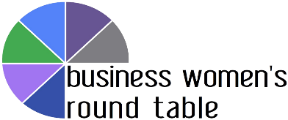

Share your story for Women’s History Month!

Please email this document to annmarie.hohenberger@cvillechamber.com when you’re done.

Your name, job title and organization

What kind of work do you do? (* Required)

Answer one or more of the questions below.

What goals and values motivate your work?

Tell us about a woman whose work you admire. How does she inspire you?

In your career so far, what positive personal changes have helped you to be more impactful?

What’s your advice for young women starting their careers?

Based on your experiences, what can workplaces do to better support women’s success?

What podcast, book or film has helped you be your best self at work?

