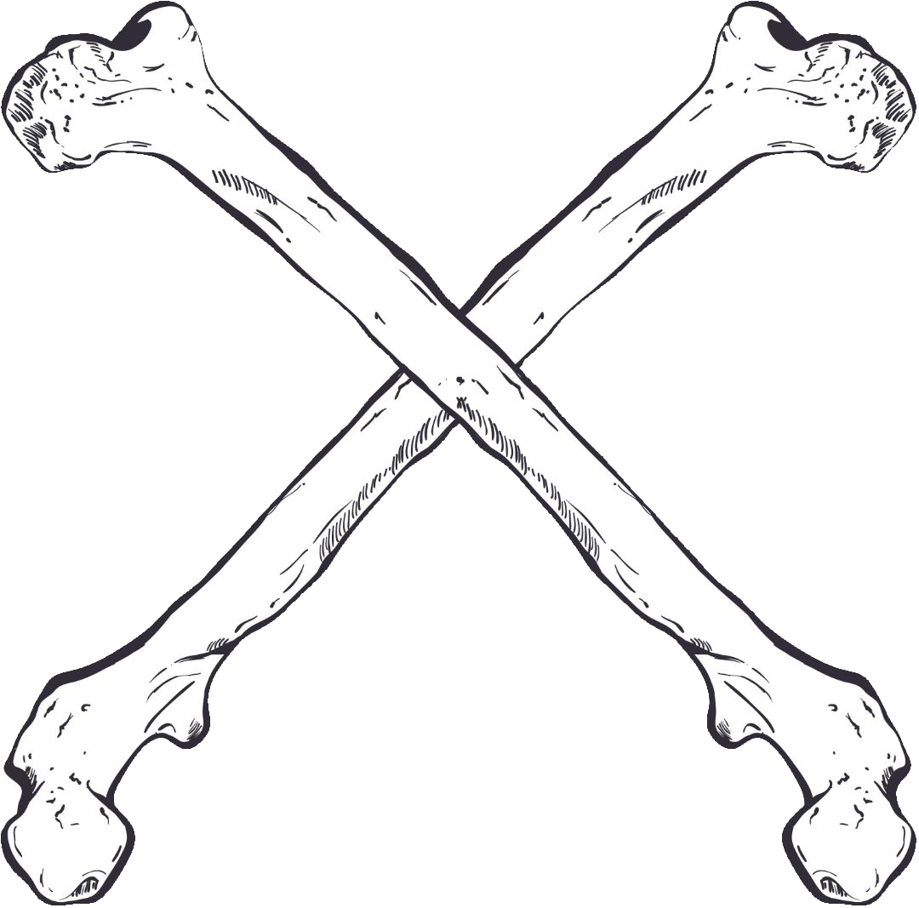
U.S. Military Vets MC

CROSSBONES Chapter

4051 Barrancas Ave PMB #246

Pensacola, Florida 32507

Date: 12/1/2019

Subject: Sponsorship Request

This letter is to introduce you to Andrew ‘Hagrid’ Kelleher who is a member and/or representative of the Crossbones chapter of the U.S. Military Vets Motorcycle Club, Pensacola, Florida.

The U.S. Military Vets MC is a 100% veteran-based, non-profit organization. Our Tax Identification Number is 83-1473718.

The U.S. Military Vets MC, Crossbones Chapter is hosting their 4th Annual Communities Caring at Christmas Poker Run on Saturday, November 14, 2020. Majority proceeds from this event go towards supporting Communities Caring at Christmas, a local charity that donates toys and money to children living in poverty and foster care in Escambia, Santa Rosa, and Okaloosa counties.

Our 2019 event attracted over 100 participants, allowed us to donate more than $4200, and over 250 toys! We are hoping to make this year even bigger than before, and that’s where you come in! With your help we know that we can reach our goal and give back to our community in a big way.

Your sponsorship support would be greatly appreciated by the Pensacola CROSSBONES Chapter, U.S. Military Vets MC, the National U.S. Military Vets MC, and, most importantly, the children as well as the veterans who will ultimately benefit from this event.

The attached sponsorship form describes the different levels of sponsorship and what each level entails.

If you have any questions or comments please feel free to contact me at 850-208-4180 or send us a message at our Facebook page @usmvmcfl20.

Thank you for your time and Sponsorship. We look forward to working with you in the future.

Andrew “Hagrid” Kelleher

Andrew “Hagrid” Kelleher

Vice President

U.S. Military Vets MC
CROSSBONES Chapter, Pensacola, FL

