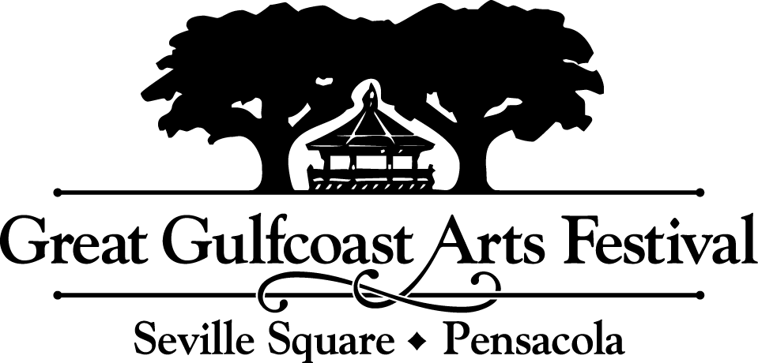

FOR IMMEDIATE RELEASE

Media Contact: Erin Kaylor: erin@duncanmccall.com
Media resources are available at www.ggaf.org/media

Call to Artists:
Poster competition for 2020 Great Gulfcoast Arts Festival is now open

PENSACOLA, FLA - June 18, 2020 – Here’s a chance to become a part of Pensacola’s art history! The Great Gulfcoast Arts Festival is accepting submissions to its 2020 poster design competition through August 7.
The winning artist receives a $1,000 cash award. The winning design will be featured on posters, T-shirts and other GGAF promotional items for the festival. Posters have become a regional collector’s item.
GGAF is one of the best-regarded, most popular arts festivals in the United States. The three-day juried art show draws more than 200 of the nation's best painters, potters, sculptors, jewelers, graphic artists, craftsmen and other artists.
This year’s event is Nov. 6, 7 and 8 in Seville Square and Bartram Park in historic downtown Pensacola.
The Festival is ranked #9 in the nation by Sunshine Artist Magazine, and the American Bus Association has named the Great Gulfcoast Arts Festival one of the Top 100 Events in North America.
Competing artists can find the complete list of rules and requirements at www.ggaf.org/poster.
Entries need to be mailed or delivered to Duncan McCall Advertising, 4400 Bayou Boulevard, Suite 11, Pensacola, Florida 32503.
For more information or to contact GGAF, visit www.ggaf.org.
###

