Digital Boardwalk, Inc. Ranked Among Florida’s Most Elite 501
Managed Service Providers 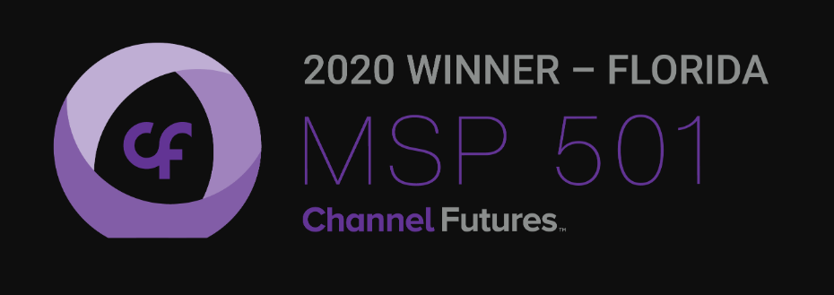

Annual MSP 501 Identifies Best-in-Class Global MSP Businesses
& Leading Trends in Managed Services

Pensacola, Florida: JULY 28, 2020: Digital Boardwalk, Inc. has been named as one of the world’s premier managed service providers and one of the top MSPs in Florida on the prestigious 2020 annual Channel Futures MSP 501 rankings.

For the 13th year, MSPs from around the globe completed an exhaustive survey and application this spring to self-report product offerings, annual total and recurring revenues, profits, revenue mix, growth opportunities and company and customer demographic information. Applicants are ranked on a unique methodology that weights revenue figures according to long-term health and viability; commitment to recurring revenue; and operational efficiency.

Channel Futures is pleased to name Digital Boardwalk, Inc. to the 2020 MSP 501.

“2020 has presented new unprecedented challenges for everyone with the COVID-19 pandemic—one we have prepared for as we followed the same protocol we instituted for hurricanes, as we are headquartered in Florida,” said Tim Shoop, CEO, Digital Boardwalk. “It has transformed the way we live, work and communicate with our employees and clients. I am both humbled and optimistic that all businesses that adapt to change will be stronger and more resilient post-pandemic. I am happy to have once again made this list, which is feedback that we have built a resilient and client focused business model. But at the same time, my heart goes out to all of the small businesses that struggled or disappeared this year.”
In the 13 years since its inception, the MSP 501 has evolved from a competitive ranking list into a vibrant group of service providers, vendors, distributors, consultants and industry analysts working together to define the growing managed service opportunity.

“These benchmarks are what local businesses should examine when choosing a managed service provider with the experience, skill set, business knowledge and defined strategy to help them succeed in this fast-changing digital landscape,” says Kris Blackmon, Senior Content Director, Channel Partners and Channel Futures. “In all of the managed service providers that Florida has to offer, Digital Boardwalk, Inc. stands as a shining example of excellence.”

Ten MSP 501 special award winners will be recognized at the MSP 501 Awards Gala at Channel Partners Virtual: Digital Events for the Modern Channel on September 8 – 10. Nominations for these special awards, including Digital Innovator of the Year, Executive of the Year and the Newcomer Award, were included in the MSP 501 application, and all candidates were encouraged to submit for them.

The data collected by the annual MSP 501 program drives Channel Partners’ and Channel Futures’ market intelligence insights, creating robust data sets and data-based trend reports that support our editorial coverage, event programming, community and networking strategies and educational offerings. It serves as a lynchpin to dozens of programs and initiatives.

The complete 2020 MSP 501 list is available at Channel Futures.

Background

The 2020 MSP 501 list is based on data collected by Channel Futures and its sister site, Channel Partners. Data was collected online from Mar. 1 through June 30, 2020. The MSP 501 list recognizes top managed service providers based on metrics including recurring revenue, profit margin and other factors.

About Digital Boardwalk
Digital Boardwalk provides comprehensive technology management and consulting
Services for small and medium-sized businesses across the country. We help customers
Achieve reliability, security, and peace of mind through award-winning support,
Cybersecurity, cloud computing and backup services. We know that technology is
Integral to your business, so we work diligently to keep your technology working for our clients.

Our team of certified technology specialists bring their individual expertise and knowledge to each job at hand. Together, we promise to provide you with the best customer service experience, industry-leading technology, and continuous innovation, all catered to your specific needs.

Read more about Digital Boardwalk’s mission here: https://www.digitalboardwalk.com

Contact Carol Bridges, Customer Engagement Manager, carol.bridges@digitalboardwalk.com

About Informa Tech

Channel Futures, Channel Partners Online, Channel Partners Conference & Expo and Channel Partners Evolution are part of Informa Tech, a market-leading B2B information provider with depth and specialization in the Information and Communications (ICT) Technology sector. We help drive the future by inspiring the Technology community to design, build and run a better digital world through our market-leading research, media, training and event brands. Every year, we welcome 7,400+ subscribers to our research, more than 3.8 million unique visitors a month to our digital communities, 18,200+ students to our training programs and 225,000 delegates to our events.

