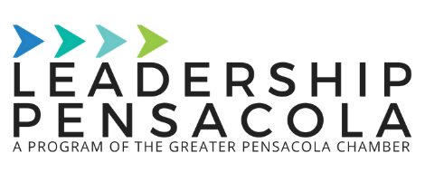
Leadership Pensacola Class of 2020
Meg Rich
(850) 426-4184
meg@megrich.com

October 7, 2020

For immediate release:

Leadership Pensacola Class of 2020 and Onbikes Pensacola complete first class project

Pensacola, Fla - The Leadership Pensacola (LeaP) Class of 2020 is completing its first project on October 17, 2020 by holding a bike giveaway to second, third, and fourth graders at O.J. Semmes Elementary.

During the 2019 - 2020 school year, members of the 2020 LeaP Class volunteered in the classrooms of all first, second, and third grade classes at O.J. Semmes Elementary to mentor students in reading and help them achieve their Accelerated Reader (AR) point goals. If all students in the class reached their AR goals, each student in the class would receive a new bike, lock, and helmet from the 2020 LeaP Class and Onbikes Pensacola. The school closures late in the year prevented the mentoring from officially coming to an end and the bike giveaway to occur, but the class has been diligent on keeping their promise to those students.

This has been a strange year for the LeaP Class. Typically, the class runs from August to May, and projects are completed prior to graduation. While COVID-19 has delayed this project completion from May until October, the LeaP Class has not given up on finishing out this project strong.

“It was never a matter of ‘if’ the project would be completed, it was just a matter of ‘when’”, said class member Chris Pinney. “We were going to fulfill our promise to these kids no matter what. We are just glad we have the opportunity to do so this fall.”

“A bike can open up a world of freedom, self-reliance, and mobility for kids, and we love partnering with other organizations that feel the same way. We’re thrilled to be a part of this project and provide incentive for these students to achieve their goals and advance their reading skills,” said Onbikes, Pensacola President, Walker Wilson.

Photos and progress can be viewed on the Pensacola Chamber of Commerce Facebook page. Please reach out to Meg Rich, LeaP class member, with any questions.

###

About the Pensacola Chamber Foundation
The Pensacola Chamber Foundation is a 501(c)(3) nonprofit organization whose mission is to drive economic prosperity and enhance the quality of life in Greater Pensacola by taking a long-term, strategic approach to regional growth and community building. Its goal is to build a healthier, better educated workforce; to continue to advance the region’s competitive economic positioning; and to improve community infrastructure by focusing on strengthening special economic interests within the region, on small business development, on minority initiatives, and on military support services. More information on Leadership Pensacola can be found on the Pensacola Chamber website.

