News Release
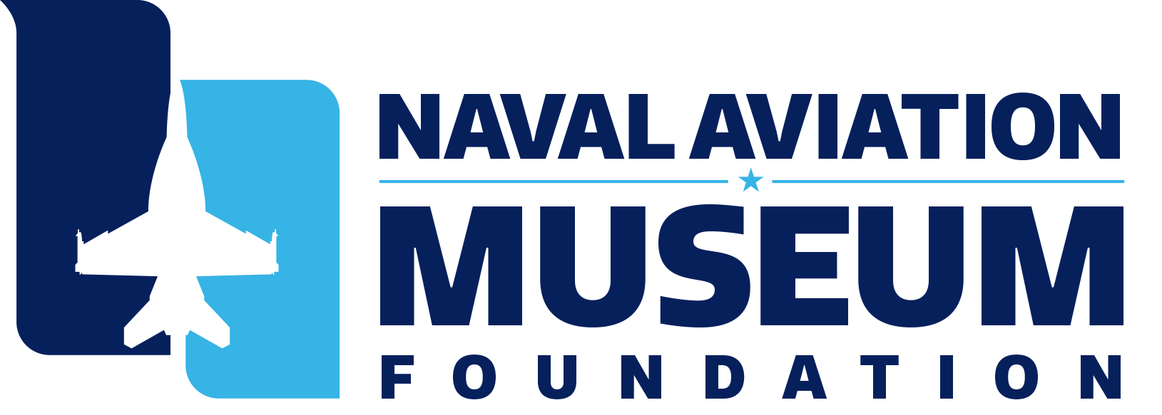
FOR IMMEDIATE RELEASE

From: Malerie Cates
Naval Aviation Museum Foundation
(850) 585-2770
mcates@navalaviationmuseum.org

Fewer Than 200 Vouchers Needed to Make the Blue Angels License Plate a Reality

Pensacola, Fla. (Dec. 18, 2020) – The Naval Aviation Museum Foundation needs the community’s help to make the Blue Angels license plate a reality. Fewer than 200 license plate vouchers are needed to get the plate into production. The Department of Motor Vehicle’s process to establish a new specialty license plate requires the Naval Aviation Museum Foundation to sell 3,000 vouchers before the plate goes into production. The voucher is redeemable for the plate once the sale requirement has been met and the plates are in production.

Florida drivers can purchase a voucher in person at a local Tax Collector’s Office or Tag Agency or online at https://bit.ly/3795qmF. The online service is available to all Florida residents residing in any county. Vouchers are available for cars, trucks, RVs or boat trailers.

It's not necessary to wait for a vehicle's registration to need renewal to purchase the Blue Angels license plate. For $30, a new plate can be ordered at any time without affecting the vehicle's registration cycle.

As a process to gain public support, the Naval Aviation Museum Foundation is offering numbered Commemorative Challenge Coins to the first 3,000 Floridians who purchase a voucher from the Escambia County Tax Collector’s website. The 1.5” antique bronze coin showcases the Blue Angels crest on the front and the words “I Helped Make History” on the back. This exclusive coin is a way to thank those who helped make the Blue Angels license plate a reality for the State of Florida.

#
Media Note: For more information about the National Naval Aviation Museum or Foundation, contact Malerie Cates at (850) 585-2770 or mcates@navalaviationmuseum.org.

##

About the Naval Aviation Museum Foundation
The Naval Aviation Museum Foundation is the nonprofit, 501(c)(3), sole benefactor to the National Naval Aviation Museum—and the fuel that allows the museum to take flight. The Foundation is responsible for funding all museum operation, expansion and activity. The Foundation works diligently to raise funding through gifts and memberships. All funding, aside from Foundation staffing and operational costs, goes to the operation, maintenance and enhancement of the museum, including museum expansion, aircraft preservation, conservation and maintenance, development of new exhibits and support of day to day functions—including custodial services, marketing, operation of the Museum's various attractions (such as our Naval Aviation Memorial Giant Screen Theater, flight simulators, Blue Angels 4D Experience and Flight Deck gift shop), as well as the production of major events at the Museum. The Foundation also supports the advancement of STEM education through the National Flight Academy, a cutting edge, aviation-themed learning experience.

###

