FOR IMMEDIATE RELEASE
Pensacola, FL April 20, 2021
Who: Baby Shark LIVE!
Where: Pensacola Bay Center
When: Saturday, June 19, 2021 at 2 p.m.
On Sale: Friday, April 23, 2021
Ticket Prices: $39.50, $44.50 and $49.50 *additional fees may apply
Children ages two and up require a ticket for admission
Tickets: Pensacola Bay Center Box Office or Ticketmaster.com
FIN-TASTIC NEWS!
BABY SHARK LIVE! IS COMING TO PENSACOLA BAY CENTER
ON SATURDAY, JUNE 19 AT 2 P.M.

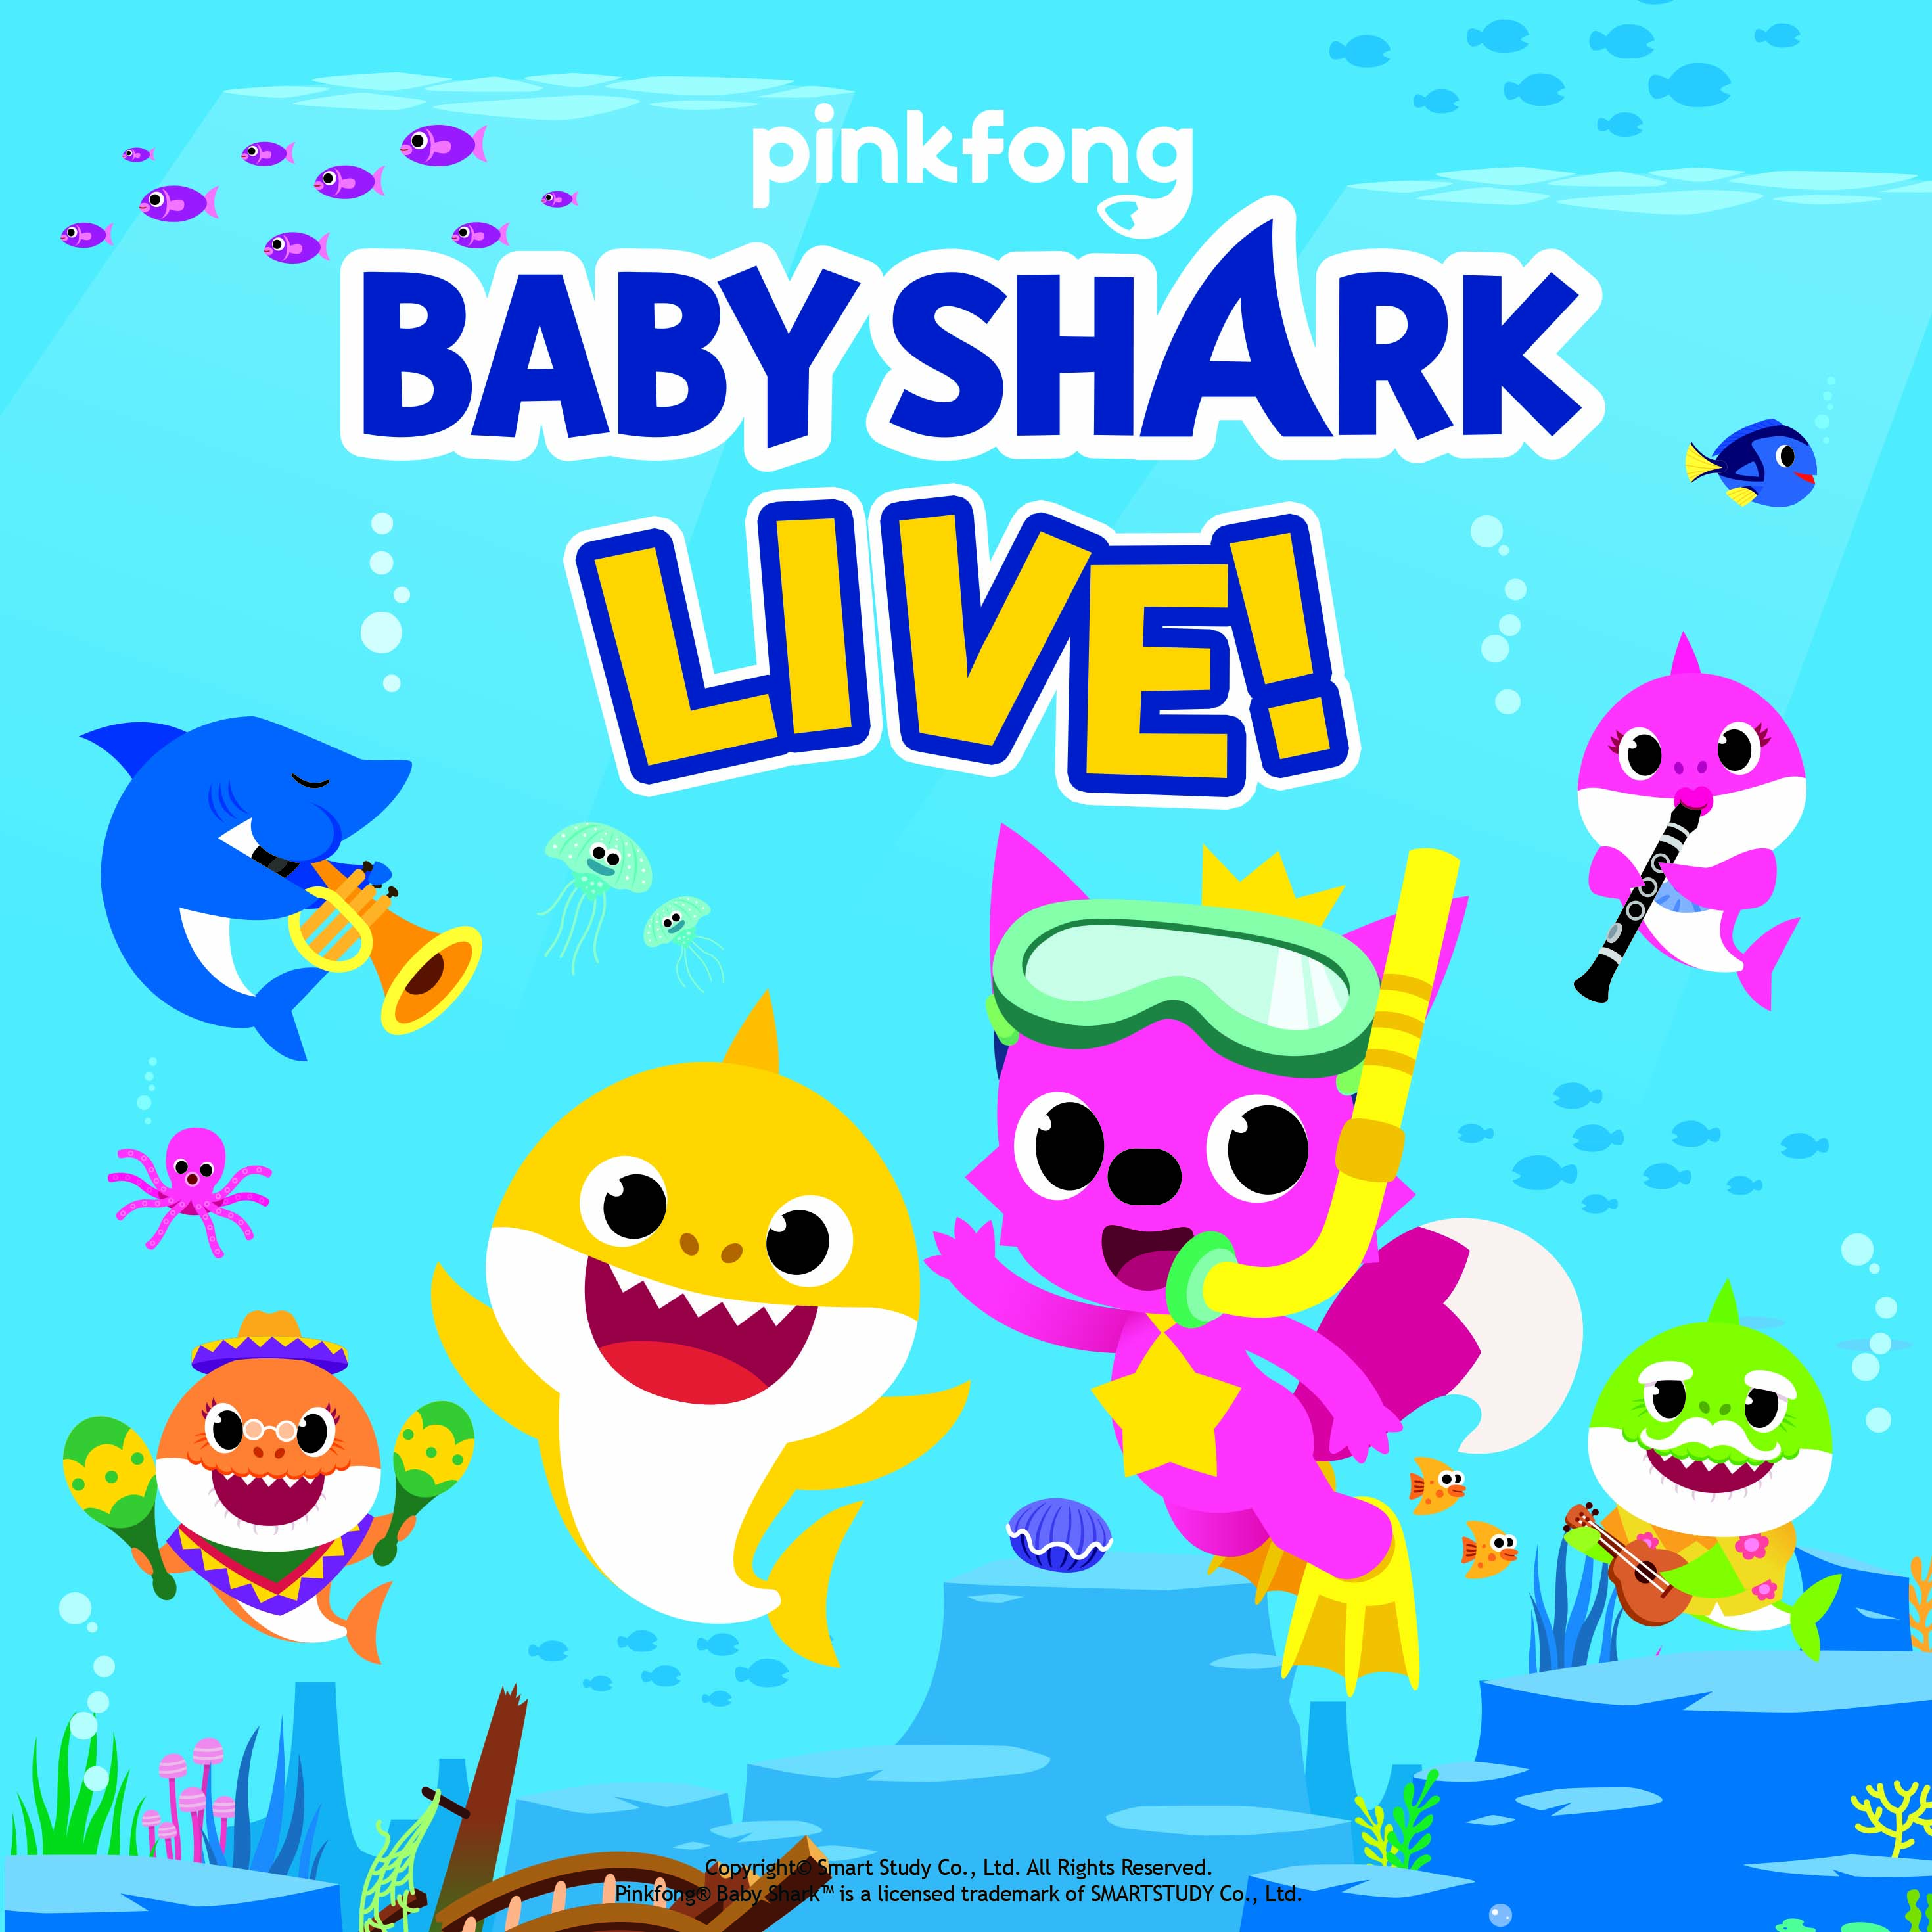

April 20, 2021 – Baby Shark Live! – the one-of-a-kind smash-hit family musical experience – will play the Pensacola Bay Center on Saturday, June 19, 2021 at 2 p.m. Tickets for this family-friendly show will go on sale to the public on Friday, April 23, 2021 at 10 a.m. and can be purchased online at Ticketmaster.com, in person at the Pensacola Bay Center or charge by phone by calling 800-745-3000.

The live show is based on Pinkfong’s viral earworm and global dance phenomenon, Baby Shark. Fans of all ages will delight as Baby Shark joins up with his friend Pinkfong to take an adventure into the sea, singing and dancing through new and classic songs including Five Little Monkeys, Wheels on the Bus, Jungle Boogie, Monkey Banana Dance and of course, Baby Shark!
- more -
Baby Shark, Pinkfong’s global hit song about a family of sharks, has climbed the charts and connected with fans around the globe. After entering the Billboard Hot 100 at #32, the song has had a 17-week streak in the Top 50 while topping the Kids Digital Song Sales Chart. The Baby Shark Dance video has over 5.7 billion views, making it the 2nd most viewed video in the history of YouTube.
Fans can visit babysharklive.com and follow Baby Shark Live! on social media for updates and exciting content.

Follow Baby Shark Live here:
Official Website: www.babysharklive.com
Facebook: @babysharklivetour
Twitter: @BabySharkTour
Instagram: @babysharklivetour

About Pinkfong:
Pinkfong is a global entertainment brand that creates award-winning kids’ content for families around the world. Pinkfong has over 4,000 songs and stories within its vast library of children’s content, which can be accessed on the App Store and Google Play, as well as on YouTube and Amazon Video. Pinkfong’s accolades include the Amazon Video Direct Star, YouTube’s Diamond Play Button and Google Play’s Best Family App of 2014-2017.

For more information, please visit the Pinkfong website, subscribe to its YouTube channel, or follow the company on Facebook and Instagram.
About Round Room Live, an Entertainment One company:
Round Room is a live entertainment company that specializes in the production and promotion of live arena shows, concert tours, theatrical performances and touring exhibitions. In 2018, Round Room was acquired by global independent studio Entertainment One (eOne), industry leaders across the family and brand space. Over the last 10 years, the senior management of Round Room has served as the Tour Producer for Bodies: The Exhibition, Executive Producer of Fuerza Bruta, Tour Promoter for An Evening with Oprah Winfrey, An Evening with Al Pacino, lead producer of Rock of Ages Broadway, Las Vegas and international, Barbra Streisand, The Marvel Experience, Jurassic World: The Exhibition and Executive Producer of The Rolling Stones Exhibitionism, all while producing and promoting some of the biggest kids tours to date, including Yo Gabba Gabba Live, Baby Shark Live and PJ Masks Live. Current projects include PJ Masks Live! Save the Day Tour, Mandela: The Official Exhibition, which launched in October 2019 in Berlin, which launched in October 2019 and Blippi The Musical which launched in February 2020.

About ASM Global:
ASM Global was formed in October 2019 from the merger of AEG Facilities, the global innovator in live entertainment venues, and SMG, the gold standard in event management. ASM Global is a venue management powerhouse that spans five continents, 14 countries and more than 300 of the world’s most prestigious arenas, stadiums, convention and exhibit centers, and performing arts venues. As the world’s most trusted venue manager, ASM Global provides venue strategy and management, sales, marketing, event booking and programming, construction and design consulting, and pre-opening services. Among the venues in our portfolio are landmark facilities such as McCormick Place & Soldier Field in Chicago, the Los Angeles Convention Center, Tele2 Arena in Stockholm, the Mercedes-Benz Superdome in New Orleans and the Shenzhen World Exhibition and Conference Centre in Shenzhen, China. ASM Global also offers food and beverage operations through its concessions and catering companies.

###

