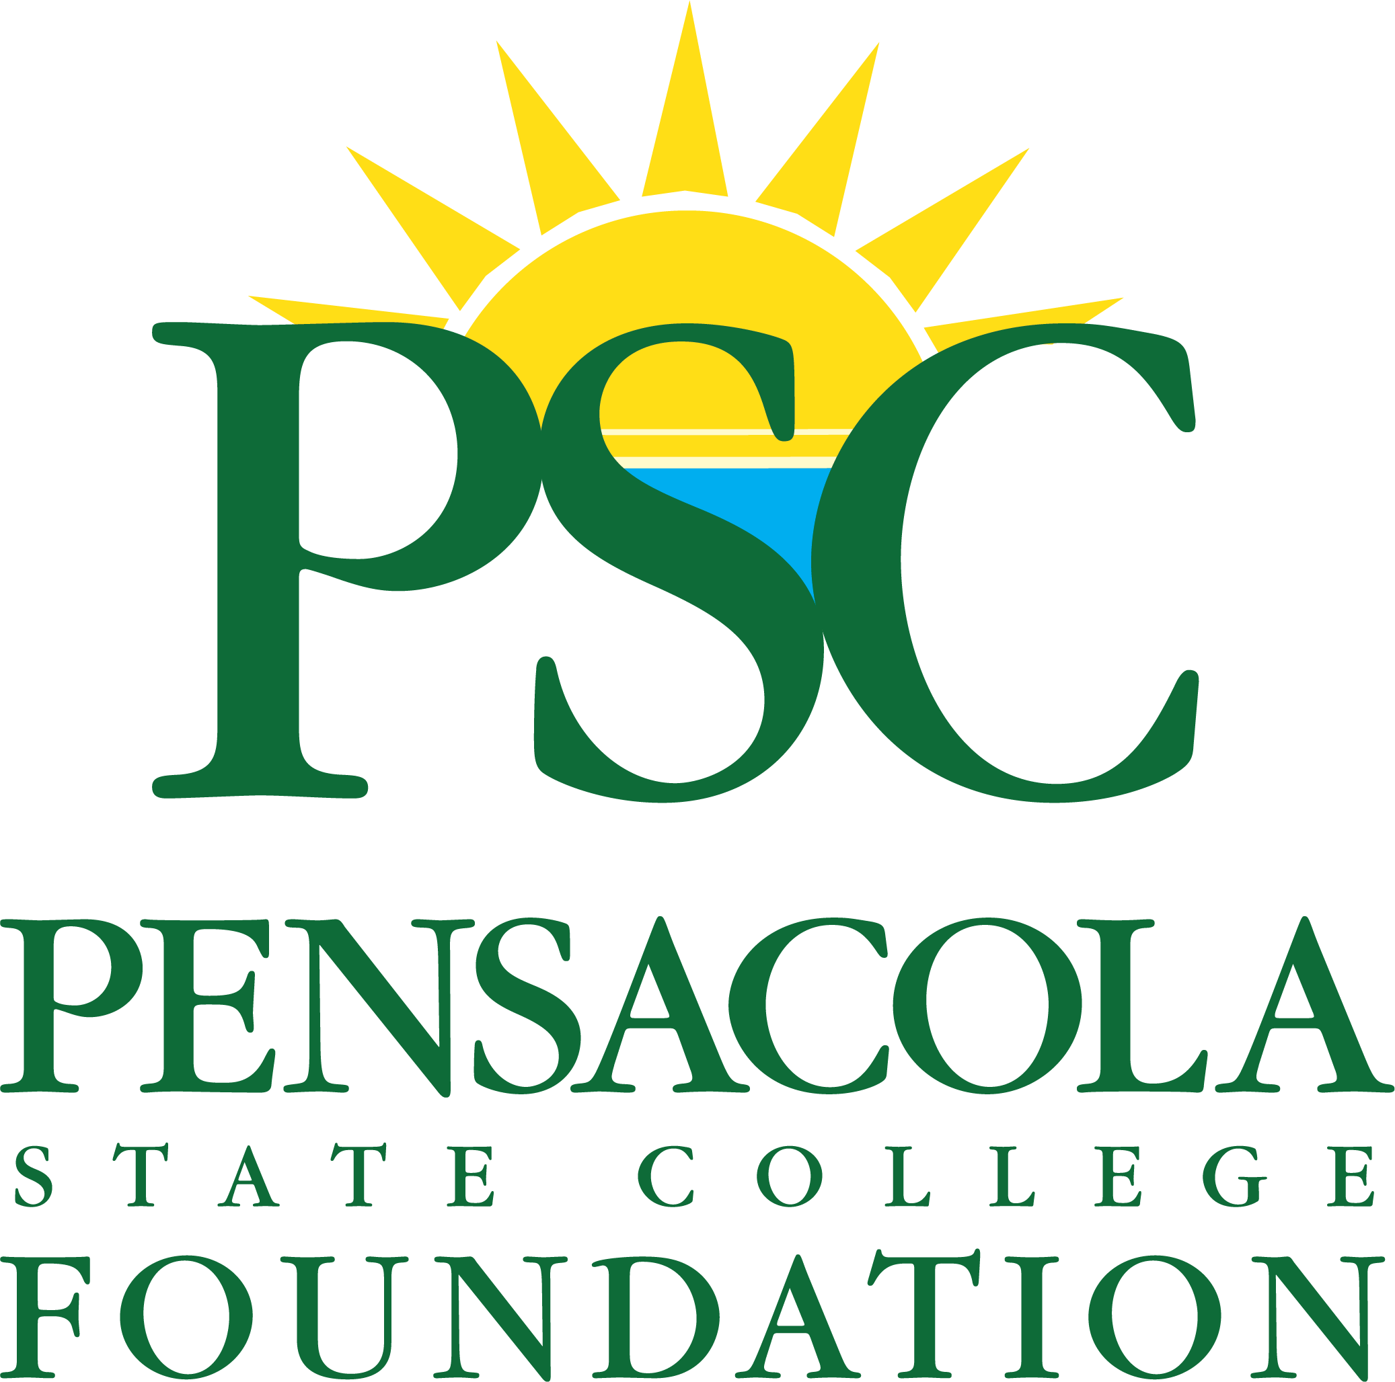 | Media Contact: Brandi Gomez  Phone: (850) 760-9343  Email: brandi_gomez@navyfederal.org

For Immediate Release

Pensacola State College Foundation brings virtual training to Navy Federal leaders; hopes other organizations jump on board

PENSACOLA, Fla. (April 28, 2021) – Pensacola State College Foundation’s Nonprofit Center for Excellence and Philanthropy is partnering with Navy Federal Credit Union to provide extensive training for its team members who serve on over 50 boards throughout the country. The extra step taken to fund training stems from the credit union’s commitment to serve in its communities.

“The Navy Federal team is consistent in showing up and pouring back into their communities,” said Andrea Krieger, executive director of institutional development for Pensacola State College Foundation. “By providing funding for this training, Navy Federal gives us the ability to share tools and resources that can elevate the expertise these leaders already have so they can best serve their organizations.”

The three-part virtual training series will focus on board service fundamentals such as strategic planning, fundraising, and governance. The Nonprofit Center has several workshops planned, both virtual and in-person, and will soon announce the launch of a new certificate program for fund development professionals.

“Given the challenges of this past year, organizations, especially nonprofits, simply do not have the budget to provide training to their boards,” said Krieger. “When business leaders and organizations like Navy Federal prioritize this kind of professional development, it reaps tremendous benefits for everyone involved.”

Navy Federal leaders who serve on boards are part of the credit union’s newly formed Community Board Service Program, which encompasses employees from the Greater Pensacola area as well as Navy Federal's Headquarters and Winchester Operations Center in Virginia. In 2020, Navy Federal also added the benefit of eight paid volunteer leave hours per year to every team member.

“Our team members often mend their passion and purpose together when giving back,” said Jennifer McFarren, Navy Federal’s manager of community and education outreach. “The pandemic has not slowed their willingness to be engaged in volunteer efforts and serve in leadership capacities to support the mission of impactful organizations we partner with.”

In 2019, the Pensacola State College Foundation launched a nonprofit center to help support training and education of nonprofit professionals and the key volunteers who make the social sector in Northwest Florida a vibrant source of support for those in need. To learn more about the Nonprofit Center and its training opportunities, please visit foundation.pensacolastate.edu or send an email to nonprofitcenter@pensacolastate.edu.

About the Pensacola State College Foundation: The mission of Pensacola State College Foundation is to support the long-range plan of Pensacola State College by raising financial support to enhance scholarships, programs, faculty, facilities, and improvements to further enhance student accessibility and the learning environment at Pensacola State College.
About PSCF’s Nonprofit Center for Excellence and Philanthropy: In 2019, the Pensacola State College Foundation launched a nonprofit center to help support training and education of nonprofit professionals and the key volunteers who make the social sector in Northwest Florida a vibrant source of support for those in need. With the generous support of a founding partner, the center hosted an inaugural nonprofit summit and four training sessions led by national experts.
About Navy Federal Credit Union: Established in 1933 with only seven members, Navy Federal now has the distinct honor of serving over 10 million members globally and is the world’s largest credit union. As a member-owned and not-for-profit organization, Navy Federal always puts the financial needs of its members first. Membership is open to all branches of the armed forces and their families. Dedicated to its mission of service, Navy Federal employs a workforce of over 22,000 and has a global network of 344 branches. For more information about Navy Federal Credit Union, visit navyfederal.org.
###

