FOR IMMEDIATE RELEASE
Media Contact:
Joe Weber
jwweber@feldinc.com
908-616-8687
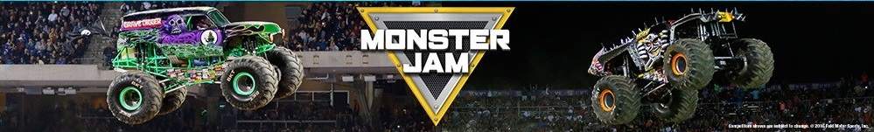

Monster Jam® Returns for an Action-Packed Weekend of Family Fun in Pensacola from July 24 – 25

Enhanced Health and Safety Measures Implemented for Fan Wellness

Pensacola, Fla.– This. Is. Monster Jam®! The most action-packed motorsports experience for families in the world today returns to Pensacola for a high-octane weekend at Pensacola Bay Center on Saturday, July 24 through Sunday, July 25 at full capacity. Monster Jam®, making its first Pensacola stop following a pandemic pause, features the ultimate mix of high-flying action and four-wheel excitement. Tickets start at $20 on ticketmaster.com and go on-sale to the general public on June 15. Fans can still sign up for free to become a Monster Jam Preferred Customer and get exclusive access to the pre-sale offer code.

As the pandemic recovery progresses, Monster Jam is monitoring changes to government mandates, public health guidelines and industry standards and is working closely with our venue partners to adjust protocols for the safety and wellness of guests based on state and local requirements. For details about Monster Jam’s Ultimate Lineup for Fan Wellness, please go here. Face coverings are strongly encouraged and may be required per venue policies. Please wear a face covering if you are not fully vaccinated, as recommended by the CDC. More information about Pensacola Bay Center’s safety policy can be found here.

The Monster Jam Pit Party will return to Pensacola on Saturday and Sunday afternoon. At the Monster Jam Pit Party, you can see the massive trucks up close, watch live pre-race interviews and participate in Q&As with the drivers, get pre-signed autograph cards, take pictures and enjoy other family-friendly fun. Face covering rules apply.

Monster Jam has reimagined the live event guest experience and created contactless shopping for fans to order merchandise in advance or onsite from the comfort of their seat. Once ordered, guests can pick up their items at a convenient, contactless pickup station during the live event. Additional information can be found here.

Pensacola fans will witness a fierce battle for the event championship with each skilled Monster Jam athlete tearing up the dirt with gravity-defying feats in 12,000-pound Monster Jam trucks going head-to-head for points in Freestyle, the Skills Challenge and Racing competitions. Plus, fans can become part of the action by voting for the winner in the Skills Challenge and Freestyle competitions via real-time, in-stadium fan voting on their smartphones.

The all-star truck lineup will feature multiple fan favorites including Krysten Anderson in the legendary Grave Digger®, the GUINNESS WORLD RECORD™ holder for the highest monster truck ramp jump. Tristan England gets behind the wheel of Megalodon®, the truck that redefined the phrase “jumping the shark”.

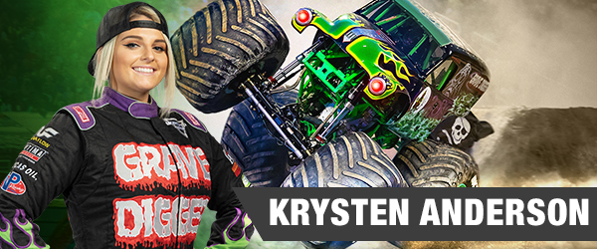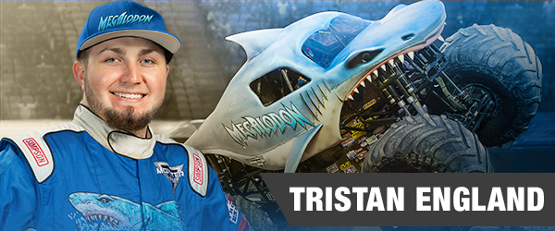

The Pagliarulo brothers, Matt and Nick, take on the field in Jester and Kraken. Rounding out the epic six-truck lineup will be Buddy Tompkins in Xtermigator and Jack Brown in FTI Torque.

Monster Jam drivers are trained, world-class male and female athletes who have mastered not only the physical strength and mental stamina needed to compete, but the vital dexterity to control 12,000-pound machines capable of doing backflips, vertical two-wheel skills and racing at speeds up to 70 miles-per-hour to produce jaw-dropping, live motorsports action seen around the world.

WHEN:
Saturday, July 24, 2021 –1:00pm & 7:00pm| Pit Party 11:00am – 12:00pm
Sunday, July 25, 2021 – 2:00pm | Pit Party 12:00pm – 1:00pm
WHERE: Pensacola Bay Center | 201 E Gregory St, Pensacola, FL 32502
TRUCK LINEUP: Grave Digger® driven by Krysten Anderson; Megalodon® driven by Tristan England; Jester driven by Matt Pagliarulo; Kraken driven by Nick Pagliarulo; Xtermigator driven by Buddy Tompkins; FTI Torque driven by Jack Brown.
**Truck and driver line-up subject to change

TICKETS: Event Tickets start at $20 each*
Pit Party Passes are $20 each*
Tickets will be available for purchase online at ticketmaster.com
*Ticket prices subject to change – venue/ticketing fees may apply.

PHOTO/VIDEO ASSETS: Media can download truck/driver photos and other press materials directly here.

For more info about a Monster Jam event near you, follow Monster Jam on our social media channels: Facebook, Twitter & Instagram. Subscribe to the Monster Jam YouTube Channel at http://www.youtube.com/MonsterJam

###

About Feld Entertainment, Inc.
Feld Entertainment® is the worldwide leader in producing and presenting live family entertainment experiences that bring people together and uplift the human spirit. Properties include Monster Jam®, Monster Energy Supercross, Disney On Ice, Disney Live!, Marvel Universe LIVE!, Sesame Street Live!, DreamWorks Trolls The Experience and Jurassic World Live Tour. Across the brand portfolio, Feld Entertainment has entertained millions of families in more than 75 countries and on six continents. Visit feldentertainment.com for more information.

About Monster Jam
Unexpected, unscripted and unforgettable, Monster Jam® features world-class athletes competing for championships on perfectly engineered dirt tracks that push these ever-evolving, state-of-the-art trucks to the limit. Beyond the 350 global live events each year, the Monster Jam brand extends off the track into the home through products, content and merchandise that keeps the fun alive year-round. For more information, visit MonsterJam.com.

