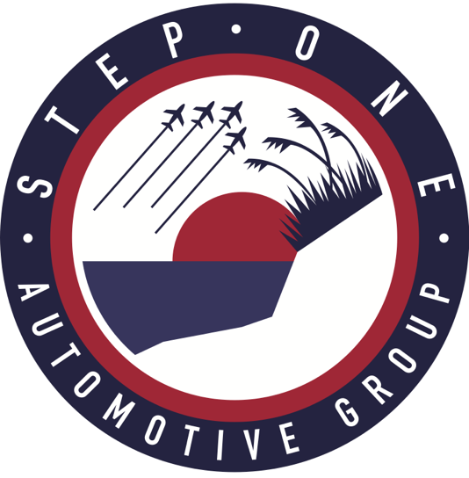

Contact:
Proffitt PR
Taylor Sheekley
Taylor@proffittpr.com
(850) 460-7777

Step One Automotive Group Launches Maserati to Pensacola Market
Multi Chamber Ribbon Cutting set for Thursday, July 15

PENSACOLA, Fla. (June 21, 2021) – On Thursday, July 15, from 5:30-10:30 p.m., Step One Automotive Group will host a Summer Celebration and multi-chamber ribbon cutting to welcome the company’s newest luxury point, Maserati Pensacola, to the Step One family.

Guests are invited to the recently built, 9,637-square dealership, located at 5600 Pensacola Boulevard, that is unlike any other in the area. Step One’s Maserati location will showcase an extensive selection of new vehicles for sale as well as a carefully inspected lineup of pre-owned vehicles. The new business will generate 20-25 full-time jobs including their sales team, finance center, and experienced team of technicians.

“We are so happy to bring luxury Italian brands like Maserati to the Northwest Florida area and to the Step One family,” said Step One Automotive Group’s Maureen Bierman. “We welcome everyone in the community to come see for themselves and experience the heritage and performance of this iconic Italian brand.

The elegant summer celebration will kick off with a multi-chamber ribbon cutting at 5:30 p.m. with the Greater Pensacola Chamber, Pensacola Beach Chamber of Commerce, Gulf Breeze Area Chamber of Commerce, Navarre Beach Area Chamber of Commerce, and the Gulf Coast Minority Chamber of Commerce, to commemorate the official launch of Maserati to the Pensacola market. The doors will then open at 6 p.m. and guests will be greeted by a glass of champagne, photo opportunities, sushi and heavy hors d’oeuvres by Signature Catering of 30A, hand-crafted Italian cocktails by Old Hickory Whiskey Bar, gelato, and much more. The event will close with an epic fireworks display. Guests are encouraged to wear their most elegant summer whites to the party.

The Summer Celebration is free and open to the public. Those planning to attend must RSVP online at http://bit.ly/CiaoBellaMaserati.

###

About Step One Automotive Group

Step One Automotive Group is an American company based in Florida that was built on a singular dedication to empowering lives through smarter and easier ways of accessing mobility.

Step One Automotive Group owns 18 dealerships in Florida and Georgia, representing 16 brands including Chrysler, Dodge Jeep, Ram Fiat, Volkswagen, Subaru, Kia, Hyundai, Genesis, Ford, Buick, GMC, Cadillac, Alfa Romeo and Maserati.

Step One Automotive Group is driven by a mission to leverage technology to disrupt the local automotive retail business. Invest in their teams, empowering them to serve. Leave a lasting legacy in their local communities achieving excellence in execution and adding value to the customer experience; always maintaining a strong financial position.

Please visit https://www.steponeautomotive.com/ and https://www.facebook.com/steponeauto/ for more information on Step One Automotive Group.

