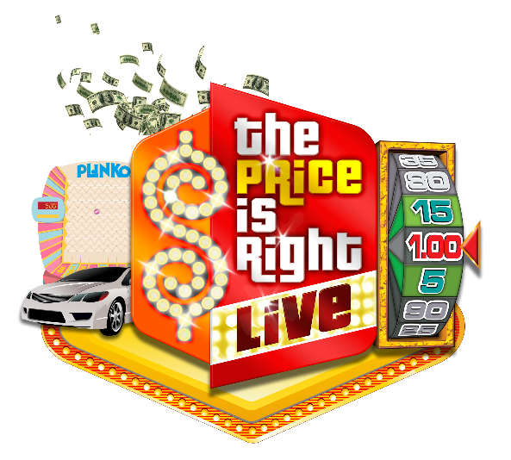

The Price is Right Live™ is coming to
Saenger Theatre on April 2, 2022

(Pensacola, FL) – The Saenger Theatre will play host to The Price is Right Live™ stage show on April 2, 2022.

Tickets will go on sale Friday, June 11, 2021 at 10:00 a.m. at Ticketmaster.com and the Saenger Theatre Box Office
The Price Is Right Live™ is a sellout interactive stage show that gives eligible individuals the chance to "Come On Down" and play classic games made famous by the iconic network television show, The Price is Right™. Contestants can win cash, sought-after appliances, epic vacations and, of course, a brand-new car by playing favorites like Plinko™, Cliffhangers™, The Big Wheel™ and the fantastic Showcase!
Showing to sold-out audiences for more a decade and counting, The Price Is Right Live™ has given away over 12 million dollars in cash and prizes to lucky audience members all across North America.

The Price is Right™ remains network television’s #1 daytime series and the longest-running game show in television history. As a beloved piece of American pop culture, Price and its games are cherished by generations of viewers. This live travelling stage show version offers fans the chance to make dreams come true and relive feelings of nostalgia, while experiencing the same thrilling excitement of winning big, up close, locally and in-person.

EVENT: The Price is Right Live!
DATE/TIME: Saturday, April 2, 2022 at 7:30 p.m.
VENUE: Saenger Theatre
TICKETS ON SALE: Friday, June 11, 2021 at 10:00 a.m.

For more information, follow The Price Is Right Live™ on Facebook (https://www.facebook.com/priceisrightlive), Twitter (https://twitter.com/TPIRLIVE) & Instagram (https://www.instagram.com/priceisrightlive/).
*The safety of our guests, cast and crew remains paramount. In addition to any state, local and venue-specific protocols, The Price Is Right Live™ will have its own COVID-19 protocols in place.*

NO PURCHASE NECESSARY. Open to US & Canada legal residents, 18+ (Residents of PR & Quebec ineligible to participate as contestants). For complete rules & regulations, including eligibility requirements & free method of entry, visit or call the box office. Sponsored by Good Games Live, Inc. Void where prohibited. Price is Right: ®/© FremantleMedia Netherlands. 2021. All Rights Reserved.
###

