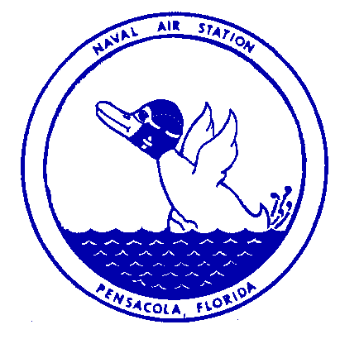Naval Air Station Ph: (850) 452-4466
Public Affairs Office Joshua.cox4@navy.mil
Pensacola, Florida

Press Release

FOR IMMEDIATE RELEASE July 16, 2021

ECSD and NASP Joint Military Council Meeting July 22
Escambia County School District (FLA) and Naval Air Station Pensacola leaders will hold the next meeting of the ECSD NASP Joint Military Council on July 22, 2021. The meeting will take place at room 102 of the Spencer Bibbs Center, located at 2005 N 6th Ave, Pensacola, FL 32503, from 4 – 5:30 p.m. The public is invited to attend the meeting.

Questions for the council to address may be submitted prior to the meeting by emailing pensacolapao@gmail.com.

The mission of the ECSD NASP Military Council is to improve educational services and communication between the Escambia County School District and military families. The Council Co-Chairs are ECSD’s Assistant Superintendent for Curriculum and Instruction, Steve Marcanio and NAS Pensacola’s Executive Officer Commander John Godbehere.

The recording of the meeting will be available following the meeting on the ECSD Military Families page, www.escambiaschools.org/military. It will also be available on Facebook on the page, Escambia Schools Public Relations and shared on the NAS Pensacola’s PAO’s Facebook page.

Please contact Joshua Cox, Deputy Public Affairs Officer, NAS Pensacola, at 850-452-4466 for any questions. Media is also invite dto attend the meeting.

---- End ----

