FOR IMMEDIATE RELEASE
July 8, 2021

Contact:
Deborah Hawkins, Executive Director
850.432.9546 or deborahhawkins@balletpensacola.org

Ballet Pensacola Hires New Artistic Director

Darren McIntyre, Artistic Director

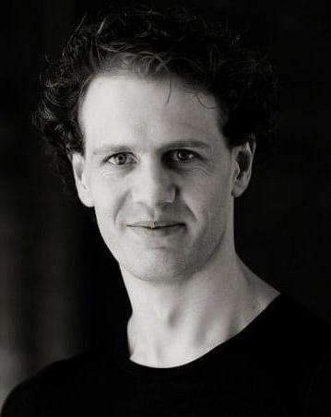
Originally from Port Macquarie, Australia, Darren McIntyre is a graduate of The Australian Ballet School where he was the recipient of The Dame Peggy Van Praagh Award for Choreography, The Sir Robert Helpmann Bursary, The Young Australian of The Year Arts Award & was a Bronze Medalist at the Society of Dance Awards Australia.

Darren was selected to represent Australia at the Prix de Lausanne in Switzerland and was invited to represent The USA at The 4th International Ballet Festival of South America in Colombia. Mr. McIntyre has been recognized by the American Guild of Musical Artists (AGMA) as an Artist of Extraordinary Ability.

Mr. McIntyre has toured extensively throughout the United States, Australia, Asia, Canada, Europe, Mexico and South America, performing a wide range of both classical and contemporary works as a freelance artist and with such companies as Louisville Ballet (KY-USA), City Ballet of San Diego (CA-USA); Milwaukee Ballet (WI-USA); Ajkun Ballet Theatre (NYC-USA, The Landestheater Detmold in Germany; The National Ballet of Ireland; and The Australian Ballet. This expanded his repertory to include the title roles in all the traditional repertory ballets & has also seen him featured in works by many reputable Innovative Choreographers.

Mr. McIntyre has also held the positions of Artistic Director, Montgomery Ballet (AL-USA); Interim Artistic Director, Lake Erie Ballet (PA-USA); Artistic Associate / Ballet Master with Fort Wayne Ballet (IN-USA), Columnist with DANCEtrain Magazine; Founder/Artistic Director of The Marianne McIntyre Memorial International Ballet Scholarship; and Casting Agent at DManagement International Dance Agency.

Darren was recently a dancer/actor with New York City’s Experience ‘The Ride’ and was honored to be featured as an original cast member in the world premiere and the first Australian Tour of the new Australian hit production "BANJO" (in the title actor/dancer role of Banjo Paterson), presented by Got Ya Back Productions, written and produced by Tim Maddren and directed by Nicholas Christo.

As a Choreographer, Mr. McIntyre has created over 30 original works & restaged and coached several full-length traditional repertory ballets. He was recently honored to be selected as a member of the Regional Dance America's National Adjudicators List and looks forward to working with them in the future.

Mr. McIntyre is excited to bring his artistic vision to Ballet Pensacola and its community and looks forward to his first season as Artistic Director with such a vibrant and inspiring organization.

Complete information about Mr. McIntyre can be viewed at www.darrenmcintyre.webs.com

.
Financial support is also provided in part by the Florida Division of Cultural Affairs and ACE.

For more information visit www.balletpensacola.org or call 850-432-9546.

About Ballet Pensacola:
Ballet Pensacola has become one of the cultural cornerstones of Pensacola, Fla. It is committed to the production of both classic ballet works and innovative originals along with its strong educational program. Located at 400 South Jefferson Street in the historic Pensacola Cultural Plaza, the organization was originally founded in 1978 as Kaleidoscope Dance Theatre. Its current operations include a performing company of 15 professional dancers augmented by talented student dancers from the Ballet Pensacola Academy. The Academy serves more than 300 students each year through its children’s, training and community divisions. For more information visit www.balletpensacola.org or call 850-432-9546.
###

