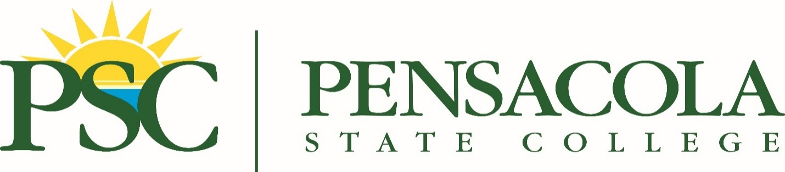
FOR IMMEDIATE RELEASE CONTACT: Sheila Nichols at 850-484-1428
Sept. 23, 2021 or snichols@pensacolastate.edu
Pensacola State Lumberjack Fest set for Oct. 9 on Milton campus
Get those flannel shirts ready! The 32nd Annual Northwest Forestry Conclave Lumberjack Festival is back.
Set for 7:30 a.m.-3 p.m. Saturday, Oct. 9, on Pensacola State College’s Milton campus, the Lumberjack Fest has moved to the fall after being cancelled in 2020 due to COVID-19.
Admission is free. Canned goods and other nonperishable food items will be collected to help stock the Milton Campus Food Pantry, which helps students in need.
“You get the whole fall feel with the flannel and the changing temperatures,’’ said Jennifer Hill Faron, dean of PSC’s Milton campus and Lumberjack Festival coordinator. “It just seems a perfect fit with the beginning of fall.”
The 2021 Lumberjack Festival will feature forestry-related competitions, including compass and pacing, knife throwing, standing chop axe throwing, cross-cut sawing and more.
The fee to compete is $5 in all events. Senior citizens, Pensacola State and high school students can compete for free. Competitors must be at least 16 years old.
Children events include face painting, coloring activities, crafts, educational exhibits and outdoor games. There also will be vendors and food trucks.
The seasonal change isn’t the only new aspect of the 2021 Lumberjack Festival. While previous festivals were behind Building 4200, this year’s festival – and subsequent festivals – will be centered at the wide-open track at the Milton campus.
“It really opens up and gives us more room,’’ Hill Faron added. “It will be easier to navigate and should be a good fit.”
Flight Factory Discs, a local disc golf retail and online company, will hold the first Lumberjack Launch disc golf tournament on the Milton campus Gator Links course. Register at https://www.discgolfscene.com/tournaments/The_Lumberjack_Launch_Presented_by_Flight_Factory_2021.
And the Pensacola State College cross-country team will host the PSC Lumberjack Invitational starting at 9 a.m. Winners of the disc golf tournament and cross-country invitational will receive Lumberjack trophies.
“The Lumberjack Festival is probably the highlight of the year for the Milton campus in terms of activities,’’ said Pensacola State President Ed Meadows. “It brings families out and it brings together a lot of our community partners. It’s a lot of fun.”
For more about the Lumberjack Festival, email LumberJack@PensacolaState.edu.
Lumberjack festival.jpg
The 32nd Annual Northwest Forestry Conclave Lumberjack Festival will be held 7:30 a.m.-3 p.m. Saturday, Oct. 9, on Pensacola State College’s Milton campus. This year’s festival will include many forestry-related competitions as well as children activities, vendors and food trucks.
Pensacola State College photo

