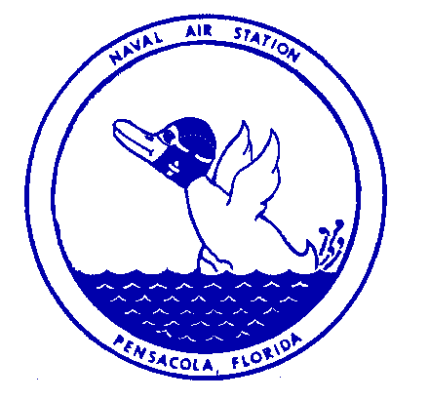Naval Air Station PH: (850) 452-4466
Public Affairs Office
Pensacola, Florida Cell: (850) 418-5185

MEDIA ADVISORY

FOR IMMEDIATE RELEASE Jan. 7, 2022

NAS Pensacola Change of Command Ceremony

PENSACOLA, Fla. — Naval Air Station (NAS) Pensacola will hold a Change of Command Ceremony at 10 a.m. on Thursday, Jan. 13, 2022, at the National Naval Aviation Museum onboard NAS Pensacola.

During the ceremony, Capt. Terrence Shashaty will assume command of NAS Pensacola from Capt. Tim Kinsella.

Shashaty, a Brooklyn, New York, native and a graduate of the U.S. Naval Academy, is reporting to NAS Pensacola following duty with the Joint Chiefs of Staff as the electronic warfare branch chief for the Deputy Directorate for Global Operations. Like all Navy aviators, Shashaty began his aviation training at NAS Pensacola and earned his pilot wings in 2000. Throughout his Navy career, he flew EA-6B Prowlers and FA-18E Super Hornets.

The ceremony is not open to the public, but media are invited to attend. To RSVP for the event, please email jason.bortz1@navy.mil by noon on Jan 12.
---USN---

