Naval Air Station Ph: (850) 418-5185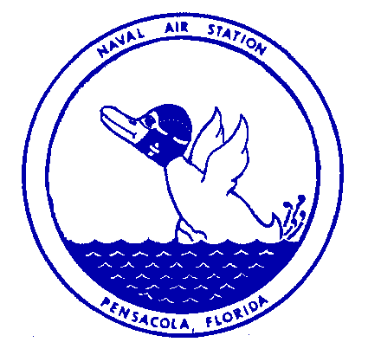

Public Affairs Office
Pensacola, Florida DSN: 459-4436

NEWS RELEASE

Jan. 27, 2022

FOR IMMEDIATE RELEASE

Navy to Conduct Force Protection Exercise

PENSACOLA, Fla – Naval Air Station Pensacola will participate in an annual force protection exercise Jan. 31 – Feb 11, 2022.

Exercise Citadel Shield-Solid Curtain 2022 is conducted by Commander, U.S. Fleet Forces Command and Commander, Navy Installations Command on all Navy installations in the continental U.S.

The exercise is designed to enhance the readiness of Navy security forces and ensure seamless interoperability among the commands, other services and agency partners.

Exercise CS-SC22 is not in response to any specific threat, but is a regularly scheduled exercise.

Measures have been taken to minimize disruptions within local communities and to normal base operations, but there may be times when the exercise causes increased traffic around bases or delays in base access. Area residents may also see or hear security activities associated with the exercise. Advanced coordination has taken place with local law enforcement and first responders.

For information about potential impacts due to the exercise, please follow our Facebook and Twitter pages.

For more information, contact NAS Pensacola Public Affairs, 452-4436, 452-4466 or 452-2552.

---USN---

