FOR IMMEDIATE RELEASE
Contact: Mike Burke
mburke@ascension.org
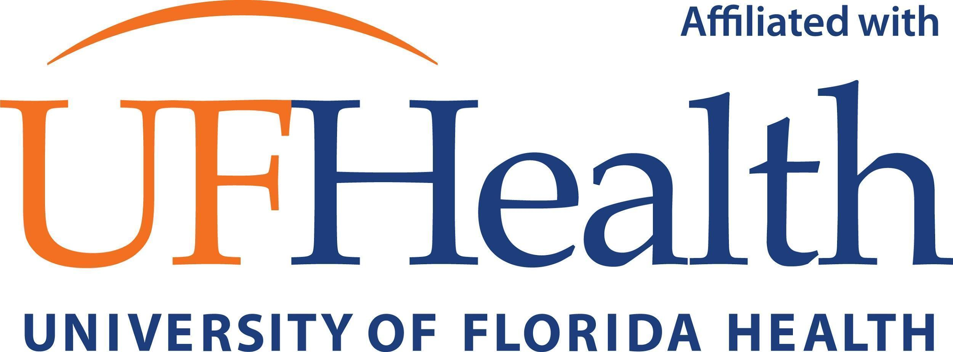

Pediatric endocrinologist joins Children’s Hospital, University of Florida Health

PENSACOLA, Fla. (Jan. 20, 2022) — Pediatric endocrinologist Katarina Gambosova, MD, has joined the faculty of the University of Florida College of Medicine, which is affiliated with the Studer Family Children’s Hospital at Ascension Sacred Heart. Dr. Gambosova will see patients full time in the Children’s Hospital and in her new outpatient office, 5153 N. Ninth Ave., on the Ascension Sacred Heart Pensacola campus.
As a pediatric endocrinologist, Dr. Gambosova diagnoses and treats problems with growth, puberty, diabetes and other disorders related to hormones and the glands that produce them. To schedule an appointment with Dr. Gambosova, call 850-416-2117.
Dr. Gambosova is a board-certified pediatric endocrinologist. She graduated with her medical degree from Komensky University in Bratislava, Slovakia. She received pediatric residency training at Regional Hospital in Povazska Bystrica, Slovakia, and at Cook County Hospital in Chicago. She then completed fellowship training in pediatric endocrinology at Yale University in New Haven, Connecticut, and at Brown University in Providence, Rhode Island. She comes to Pensacola from Stormont-Vail Hospital in Kansas, where she developed the pediatric endocrinology program for 10 years, expanding her practice from Topeka to Kansas City.
As Northwest Florida’s only children’s hospital, the Studer Family Children’s Hospital includes a pediatric emergency department, Level III neonatal intensive care unit, medical/surgical beds, observation beds, a pediatric imaging department, pharmacy, inpatient rehabilitation gym, child life playrooms, outpatient lab services and a new family-friendly dining venue. More than 120 pediatric doctors serve on the children’s hospital’s medical staff, caring for kids across 30 pediatric specialties. For more information, visit studerfamilychildrenshospital.com.
UF Health Shands Children’s Hospital is recognized among the nation’s best hospitals by U.S. News & World Report in eight pediatric medical specialties and is the No. 1 children’s hospital in Florida. In addition to pediatric specialty care, Ascension Sacred Heart and UF Health collaborate on a kidney transplant program to benefit the thousands of individuals across the Southeast awaiting a lifesaving transplant. Ascension Sacred Heart’s pediatric, OB/GYN and internal medicine physician residency programs are also affiliated with the UF College of Medicine.
About Ascension Sacred Heart
Ascension Florida and Gulf Coast includes Ascension Sacred Heart based in Pensacola, Florida, Ascension St. Vincent’s based in Jacksonville, Florida, and Ascension Providence in Mobile, Alabama. Ascension Florida and Gulf Coast operates nine hospitals and more than 200 other sites of care, employing more than 13,000 associates. Across the region, Ascension Providence, Ascension Sacred Heart and Ascension St. Vincent’s have served North Florida and South Alabama communities for more than 165 years. In fiscal year 2020, Ascension Florida and Gulf Coast provided more than $237 million in community benefit and care of persons living in poverty. Ascension is a faith-based healthcare organization dedicated to transformation through innovation across the continuum of care. As the largest non-profit and Catholic health system in the U.S., Ascension is committed to delivering compassionate, personalized care to all, with special attention to persons living in poverty and those most vulnerable. The national health system operates more than 2,600 sites of care – including 145 hospitals and more than 40 senior living facilities – in 19 states and the District of Columbia, while providing a variety of services including clinical and network services, venture capital investing, investment management, biomedical engineering, facilities management, risk management, and contracting through Ascension’s own group purchasing organization. Visit www.ascension.org.

About University of Florida Health
UF Health is the Southeast’s premier academic health center. With main campuses in Gainesville and Jacksonville, UF Health includes six health colleges, nine research centers and institutes, 10 hospitals, including two teaching hospitals and five specialty hospitals, and a host of physician medical practices and outpatient services throughout North Central, Central and Northeast Florida. Our mission is to promote health through outstanding and high-quality patient care, innovative and rigorous education in the health professions and biomedical sciences, and high-impact research across the spectrum of basic, translational and clinical investigation. Visit www.UFHealth.org to learn more.

# # #

