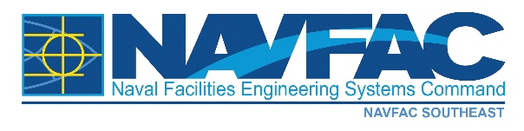
NEWS RELEASE FROM

NAVAL FACILITIES ENGINEERING SYSTEMS COMMAND, SOUTHEAST PUBLIC AFFAIRS OFFICE

MEDIA ADVISORY: Jan. 31, 2022 No. 22-09
Contact: Susan Brink, NAVFAC Southeast Public Affairs
E-mail: susan.brink@navy.mil
Voice: (904) 542-6622
Fax: (904) 542-6696

Energy improvements planned at NAS Pensacola

JACKSONVILLE, Fla. – Naval Facilities Engineering Systems Command (NAVFAC) Southeast awarded a $7.6 firm-fixed-price task order, Jan. 21, to Florida Power & Light (FPL) Company, from Juno Beach, Florida, for implementation of energy improvements at Naval Air Station (NAS) Pensacola, Florida.

The project is expected to save the Navy over $501,000 per year in utility costs.

“We are excited for the opportunity to partner with FPL to apply advanced technologies to improve our facilities and continue working toward our energy reduction goals,” said NAS Pensacola Installation Energy Manager Sabrina Hopkins.

FPL provides electric service in many areas along the east coast of Florida, the agricultural area around southern and eastern Lake Okeechobee, the lower west coast area, and portions of central, north central, and portions of Northwest Florida.

Under the contract, 18 facilities onboard NAS Pensacola will receive interior and exterior lighting upgrades. Other upgrades include water efficiency improvements at eight facilities; chiller replacement at Building 3909; heating, ventilation, and air conditioning controls upgrades in four facilities; high efficiency electrical transformer upgrades in six facilities; and medium voltage transformer and switchgear replacement at Building 514.

The energy improvement project is expected to be completed by December 2023.

####

Naval Facilities Engineering Systems Command: The Facilities & Expeditionary Combat Systems Command
NAVFAC is the Systems Command that delivers and maintains quality, sustainable facilities, acquires and manages capabilities for the Navy's expeditionary combat forces, provides contingency engineering response, and enables energy security and environmental stewardship. Additional updates and information about NAVFAC can be found on social media sites Facebook and Flickr. Become a fan at www.facebook.com/navfac, view our photostream on Flickr at http://www.flickr.com/photos/navfac.

