FOR IMMEDIATE RELEASE

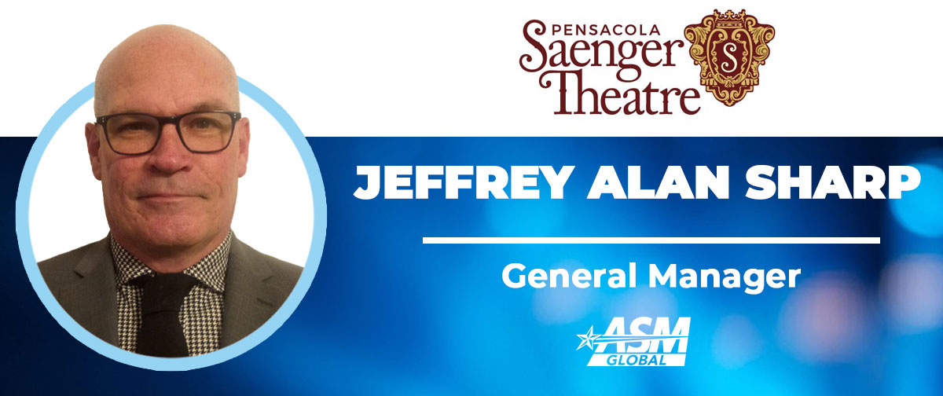

JEFFREY ALAN SHARP NAMED GENERAL MANAGER OF SAENGER THEATRE

PENSACOLA, FL. (March 4, 2022) – ASM Global, the premier venue management and services company, has appointed Jeffrey Alan Sharp as General Manager of the Saenger Theatre, located in Pensacola.
“Jeffrey is a tremendous leader within ASM Global and has been a major contributor to the overall success of the Pensacola Saenger Theater within the operations department for the past six years.” Said Tim Jorgensen, Regional Vice President of Arenas, Stadiums and Theaters for ASM Global. “I am confident I can speak on behalf of our entire ASM Global team as well as our contract administrators and valued community partners when I say that we are all thrilled to promote Jeffrey to General Manager.”
“I am looking forward to carrying on the one-hundred-year tradition of the Pensacola Saenger Theatre and being a part of the next one hundred years,” said Jeff Sharp, new General Manager of the Saenger Theatre.
-more-

Jeffrey Sharp brings with him to this role, an AS in Aviation Flight Technology, an AS in Business Management and a BS in Human Resources Management from the University of West Florida. Sharp is also a United States Army Veteran of Gulf War I. Jeff’s background also includes Restaurant Management and Commercial Building Management. Having been with the Saenger since 2015, he started out as a part time Maintenance Technician, was promoted to Maintenance Supervisor, then Operations Manager, and ultimately the General Manager.
About Saenger Theatre
The Saenger Theatre is the premier entertainment venue located in downtown Pensacola. The Theatre is home to the Broadway in Pensacola and hosts a variety of events including symphony, opera, ballet, touring concerts, family shows and community events. The Saenger Theatre is owned by the City of Pensacola and professionally managed by SMG, the world leader in venue management, marketing and development.

About ASM Global
ASM Global is the world’s leading producer of entertainment experiences. It is the global leader in venue and event strategy and management—delivering locally tailored solutions and cutting-edge technologies to achieve maximum results for venue owners. The company’s elite venue network spans five continents, with a portfolio of more than 325 of the world’s most prestigious arenas, stadiums, convention, and exhibition centers, and performing arts venues Follow us on Facebook, Instagram, LinkedIn and Twitter or visit us online at asmglobal.com

###
Contact: Kathy Summerlin
Saenger Theatre
850-595-3882 office
850-207-7944 cell

