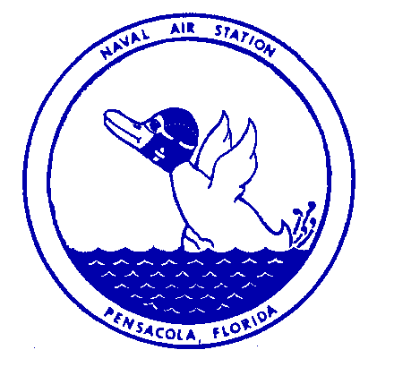Naval Air Station Ph: (850)452-4436
Public Affairs Office Cell: (850)418-5185
Pensacola, Florida DSN: 922-4436

NEWS RELEASE

FOR IMMEDIATE RELEASE April 25, 2022

NAS Pensacola Earns 2022 Navy Installation Excellence Award
NAVAL AIR STATION PENSACOLA — Naval Air Station (NAS) Pensacola was recently named the Commander, Navy Installations Command’s (CNIC) Installation (Large) of the Year for 2022. The award recognizes the top Navy shore commands for their installation management, program excellence and community outreach during fiscal year 2021.
CNIC oversees 70 U.S. Navy installations worldwide. For the Installation Excellence Awards, bases are evaluated on a number of categories including facilities management, quality of life, environment, energy, public relations, safety and mission support.
Among these criteria, NAS Pensacola completed over 50,000 mishap-free operations, 8,000 combat training activities, 7,600 radar/instrument approaches and 12 large force exercises. NAS Pensacola’s Port Operations supported 50 port calls, 110 movements and homeporting for five U.S. Coast Guard Cutters.
“NAS Pensacola is an elite group of professionals that excel at doing their job,” said Capt. Terrence Shashaty, commanding officer, NAS Pensacola. “NAS Pensacola is the second largest training base in the Navy and has 127 tenant commands to support. This award is well deserved and everyone that works on NAS Pensacola should be very proud of this accomplishment.”
Other contributing factors that supported NAS Pensacola earning this award for the first time since 2015 included a $7.6 million Utility Energy Service Contract that promoted increased energy security and resiliency to mission systems across the installation, a community-military collaboration that resulted in funding to construct offshore reef breakwaters and beach habitat, and support for two NASA/SPACEX recovery missions. The installation completed energy efficiency upgrades to 30 facilities and generated an estimated annual energy cost savings of $501,000.
NAS Pensacola also demonstrated quality of life with Moral, Welfare and Recreation, Child Youth Programs and the NAS Pensacola Galley all earning five star accreditation. During the award period, NAS Pensacola also started STARBASE Pensacola, a Department of Defense program that allows 5th graders from local Title 1 schools to learn STEM (Science, Technology, Engineering, and Math) related topics at the National Flight Academy onboard NAS Pensacola.
Public relations was also a key component of this award and Pensacola was one of five communities across the country recognized for exemplary work in improving quality of life of military personnel and their families through community-military programs, initiatives and partnerships.
“It is truly an honor to be recognized,” said Shashaty. “Since the day I arrived on the installation, I knew how special the active duty service members, civilian employees and contractors are that work here, but now, everyone across CNIC knows how special they are too. NAS Pensacola is truly a great installation and this award recognizes everyone on base and the community that supports us.”
Please continue to follow the NAS Pensacola Facebook (@NASPCOLA) and Twitter (@NASPCOLA) pages for updates.

---USN---

