[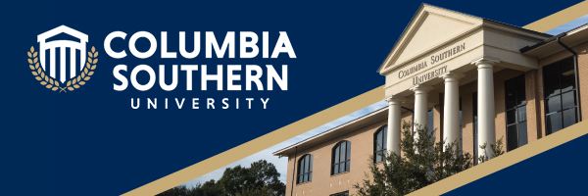](https://youtu.be/XsmWWlbl1T4)

|  |  |
| --- | --- |
| |  | | --- | | **Columbia Southern University** is pleased to have the **Greater Pensacola Area Chamber** as a Learning Partner. This partnership provides a reduced tuition, plus many additional benefits. For your convenience, all programs are available in an online format. This is an excellent employee benefit your organization can provide that may assist in recruitment and retention of personnel.  **The Learning Partner Program provides exclusive benefits to the employees/members of the Chamber, as well as spouses and children. Benefits of the partnership include:**   * 10% tuition discount on all classes and waiver of the Application Fee. * Textbooks provided at no cost. * Exclusive Scholarship Opportunities for Learning Partner employees/members. * A complimentary evaluation of previously earned college credits and training/professional certifications for consideration of transfer credit. * Complimentary access to our Writing and Math specialists through the Student Success Center. * A dedicated landing page for Learning Partners on the CSU website for prospective students and student enrollment. [https://www.columbiasouthern.edu/jim-forsythe](https://linkprotect.cudasvc.com/url?a=https%3a%2f%2fwww.columbiasouthern.edu%2fjim-forsythe&c=E,1,2O8clZLiPOyg0-TFqCekSoWdKb_jjVrFlk6Pqaq1NS4s0U54ZUHz4c-3zOxcKR_QNI2OakDOS2MIMAYr2QzvFDGLPLV3EblPjA9wP2Ea&typo=1)   **About CSU**  **Columbia Southern University** is a completely online university offering associate, bachelor’s, and graduate degree programs in a wide variety of disciplines. For program information, please contact Jim Forsythe at 800-977-8449 x 1860 or [jim.forsythe@columbiasouthern.edu](mailto:jim.forsythe@columbiasouthern.edu). | |

|  |  |  |
| --- | --- | --- |
|  |  |  |