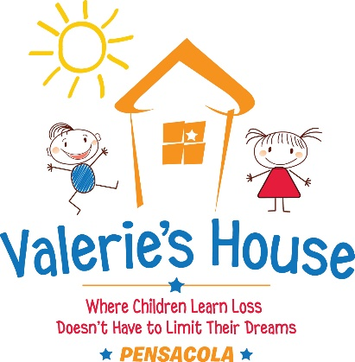

July 22, 2022

FOR MORE INFO:

Crista Brandt, Pensacola Advisory Chair
Valerie’s House
Crista@valerieshouse.org

FOR IMMEDIATE RELEASE

VALERIE’S HOUSE HIRES ESCAMBIA COUNTY PROGRAM MANAGER

Pensacola, FLA., July 19, 2022 – Valerie’s House Pensacola, a grief support organization that provides peer support groups and other services to grieving children and their families, has hired Jennifer Elzweig as Escambia County Program Manager.

Elzweig has been an integral part of Valerie’s House Pensacola since its inception, serving as a children’s group support volunteer with the elementary age children and as a Pensacola Advisory Board member.

“Having Jenni on board with us fulltime will be a game changer for how we are able to impact young lives,” said Valerie’s House Pensacola Advisory Chair Crista Brandt. “Her personal experience with grief and her former role as an Escambia County teacher makes her a great fit to work with our families.”

Elzweig identifies with many grieving families, as her father died from a stroke when she was a young adult and she recalls not having any services to help her family. She received a Bachelor of Fine Arts from the University of West Florida in 2018 and has been employed as a fine arts teacher for the Escambia County School District. She has mentored many students from very diverse backgrounds and is also a certified yoga teacher, guiding kids, young and old.

“I know how isolating grief can be, and that is why finding support and community at Valerie’s House is so important, especially for children,” Elzweig said.

Valerie’s House- Pensacola opened its doors in 2021 and has since grown to serve more than 100 children in less than two years. The chapter uses the Big Brothers Big Sisters building on Creighton Road in Pensacola for its grief support groups, which are at no cost to children and families.

The first chapter of Valerie’s House was founded in Fort Myers in 2016 by Angela Melvin, whose mother was killed in a car accident in 1987. The organization has expanded to include locations in Naples, Port Charlotte and now Pensacola.

Like Melvin, Pensacola chapter founder Crista Brandt also lost her mother as a young girl and is determined to make sure no child grieves alone in the community.

“My purpose is to make my tragedy a gift to someone else,” Brandt said. “We are so grateful to all of the supporters who have helped us grow in our community and reach children who need us.”

One in eight children in Florida is predicted to lose a parent or sibling before the age of 25, according to the 2021 Childhood Bereavement Estimation Model.

Valerie's House is a non-profit organization that is fully supported by community donations. Please go to www.valerieshouse.org/pensacola to make a donation or to find out more about enrolling a family who needs help.

###

