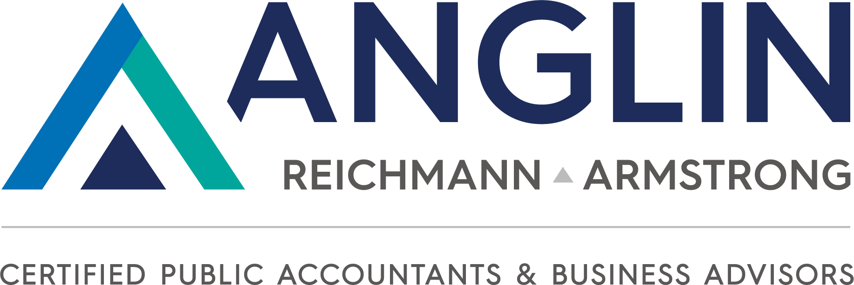

For Immediate Release
Kami Minor
kminor@anglincpa.com
(256) 533-7044

Brandon C. Smith, CPA, Named Managing Partner of Anglin Reichmann Armstrong, Effective July 1, 2022
“This announcement is more than 30 years in the making.”
– current managing partner Gary Anglin, CPA, CGMA

HUNTSVILLE, AL, June 28, 2022 — Anglin Reichmann Armstrong announced the appointment of Brandon C. Smith, CPA to Managing Partner, effective July 1, 2022. Current Managing Partner Gary Anglin, CPA, CGMA, transitions to chair of the firm’s board of directors.
This historic announcement marks the 32nd anniversary of the firm and the next chapter of its strategic plan, according to Gary Anglin. “Brandon’s role is a very intentional piece of our growth strategy, and he will continue to work closely with our internal team while also maintaining direct client contact. He has a natural skill set for building relationships and implementing strategy, which perfectly matches who we need as the next managing partner.”
Smith joined the firm in 2006 shortly after switching his career interests from computer science to accounting. He achieved his Master of Accountancy degree in 2007, and he has since served clients in a variety of industries as an outsourced CFO and business advisor. He expressed excitement for the managing partner role, noting that his background in IT and business advisory services (rather than a specific tax or audit track) is similar to the evolution of the public accounting industry today. “I grew my career at Anglin through our consulting practice, and this emphasizes where our firm is and where the profession is going — advisory services beyond compliance work.”
For example, the firm has developed and grown premier niche services in government contracting and construction as well as value-added services in business valuations, specialty tax credits and incentives and wealth management. The firm’s recent launch of a Client Accounting and Advisory Services (CAAS) practice is another area that will require the skills of talented accountants as well as IT specialists and business advisors.
Smith emphasized his management and administrative support team as well as the partner group and department heads for providing an easier transition to his new role. This includes David Bier, MBA, Chief Operating Officer; and Ryan Campbell, CPA and partner-in-charge for Pensacola, FL. Other officers and members of the firm’s board of directors include Stephen Armstrong, CPA, Jeremy Mosteller, CPA, CGMA and Scott Hand, CPA, CGMA, MBA. “Gary left big shoes to fill after growing this practice to the largest, locally owned accounting firm in Huntsville,” Smith said. “He and our leadership team will sustain that growth, helping me to focus on the firm’s future with our people and clients, which is what I love about this business.”
Anglin will maintain his focus on client consulting while being available to the management team as needed. He will stay involved in the profession through CPAmerica and state CPA societies.
“I want our team, clients and community partners to feel good about the direction of the firm. We have a plan in place for firm leaders like Brandon and our emerging leaders,” Anglin added. “Team continuity and positive local impact are the cornerstones of that strategy.”
Formed in 1990, Anglin Reichmann Armstrong, P.C. has consistently received accolades such as Best Accounting and Tax Firms and Best Places to Work. With offices in Huntsville, Alabama and Pensacola, Florida, Anglin serves clients throughout the Southeast and nationally through its niche offerings. Services include CFO Services, Outsourced Accounting, Specialized Tax Credits (R&D Credits), Business Valuations as well as Audit and Assurance and Tax Advisory Services. Anglin is a member of CPAmerica International. For more information, visit www.anglincpa.com

