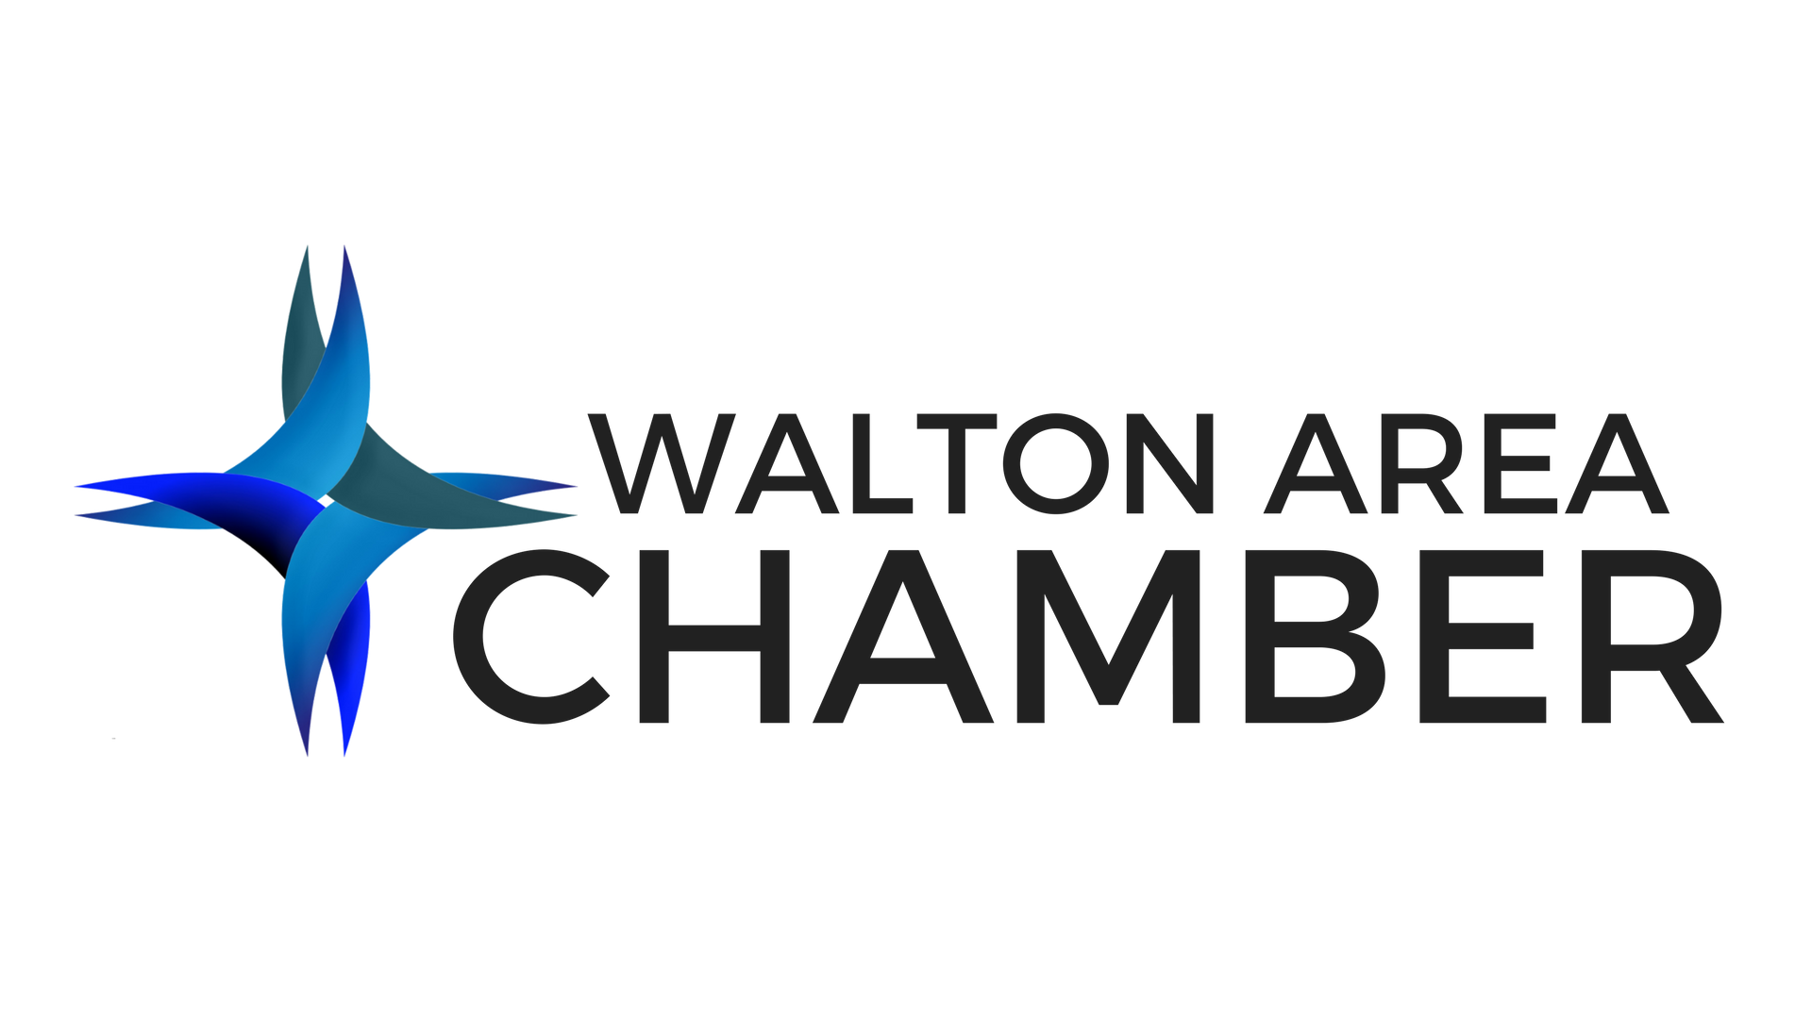

Contact:
Megan Harrison
President and CEO, Walton Area Chamber of Commerce
ceo@WaltonAreaChamber.com

Walton Area Chamber of Commerce Announces “The Next BIG Thing” Speaker Line Up

WALTON COUNTY, Fla. (August 25, 2022) – The Walton Area Chamber of Commerce is pleased to announce their official speaker lineup for their annual symposium, “The Next BIG Thing” presented by Ascension Sacred Heart Hospital on the Emerald Coast, happening Tuesday-Wednesday, September 6-7, 2022, at Hilton Sandestin Beach Golf Resort and Spa.

Throughout the two-day event, guests will hear from a variety of speakers, including keynote speakers Tom Pollard and Phillip Stutts who will be headlining the symposium event. Pollard, of Tony Speaks, will discuss building your personal brand to achieve excellence, while Stutts, of Win Big Media, will cover “The Undefeated Marketing System” and how to grow your business and build your audience using the secret formula that elects presidents.

Attendees will break out into workshop sessions throughout the afternoon that highlight one of the symposium’s distinctive growth tracks: leadership development, business and entrepreneurship, and women in business. Each of the workshops will have a featured speaker who is an expert in one of these fields:
Leadership Development:
- Dr. Elio Chiarelli, Jr., The Kidder Company
- Kateryna Armenta, Ambitious WE Life and Career Coaching
- Dianne Guthmuller, LeadershipTen
- Mark Noon, LeadershipTen
- Jeff Goldberg, Walton County Emergency Management

Business and Entrepreneurship:
- Nancy Francis, Noo F/X
- Kevin Elliott, Wewa Films
- Brooke Bailey, Zehnder

Women in Business:
- Christina Korp, Purpose Entertainment and SPACE for a Better World
- Women United Panel: Kelly Jasen, Jessica Leavins, Laurie Markoe, Ashley Mason; United Way Emerald Coast
- Jennifer Richardson, Emmanuel Sheppard and Condon

Registration and check-in begin at 8 a.m. with a continental breakfast in the vendor ballroom. “The Next BIG Thing” will begin promptly at 9 a.m. with welcoming remarks from Walton Area Chamber of Commerce CEO, Megan Harrison. Lunch, provided by Hilton Sandestin, will begin at 11:30 a.m. Day one of the symposium will conclude with a cocktail reception featuring light bites, cocktails, and raffle prizes.

The second day of the symposium will kick off with a morning workshop at 8:30 a.m. and culminate with the Chamber’s September Power of Business Luncheon featuring speaker, Mark Noon of LeadershipTen.

Tickets are on sale for $125 for a one-day pass and $175 for a two-day pass for Walton Chamber members while the cost to attend for non-members is $150 for one-day and $200 for two-days. Interested individuals can register for the event by visiting https://bit.ly/NextBIGThingRegister. Military and Group discounts are available. The event’s lodging sponsor, The Hilton Sandestin Beach Golf Resort and Spa, is also offering a group rate for those interested in convenient lodging for the two-day event. Use code WAC and call 850-267-9500 to book a reservation.

The Walton Area Chamber of Commerce would like to thank the local businesses who are already signed up to sponsor this year’s event including 850 Magazine, All In Credit Union, Clark Partington, Cox Communications, Emerald Coast Title Services, Emmanuel Sheppard & Condon, Epic Photo Co., Grand Boulevard, Hand Arendall Harrison Sale, Hilton Sandestin Beach Golf Resort and Spa, Horsley Construction Group, Silver Sands Premium Outlets, and Step One Automotive Group.

###

About the Walton Area Chamber
The Walton Area Chamber of Commerce was established in 1925 and provides leadership for a healthy business community. As the area’s leading voice of business, the more than 800-member organization represents the interests of business with government, promotes the local community and provides business education and networking opportunities toward building a strong Walton County economy. For more information, visit www.waltonareachamber.com or call 850-267-0683.

