2300 North Tarragona Street MiniHome
This Escambia County Housing Finance Authority’s (“Authority” or “Board”) project began in 2016 when Steve Jernigan (former Authority Board Member), an Architect at Bay Design, suggested that the Authority partner with the University of South Florida School of Architecture (“USF”) to design a tiny or MiniHome alternative. USF ultimately produced a “permit ready” set of construction plans. The plans for the MiniHome Prototype were approved by the Authority Board on April 11, 2017. In November 2017, the Authority approved the purchase of 2300 North Tarragona Street for the MiniHome project.
In May 2018, the MiniHome Construction Trades Demonstration Agreement with Pensacola State College (“PSC”) was approved. Since then, the PSC Vocational Carpentry Certificate Program has prepared students for a career in carpentry as a residential or small commercial carpenter. Being able construct the PSC house from the ground up, has given these students experiences that can accent their resumes, including remodeler, trade foreman, project superintendent, or residential contractor. This program emphasizes both hands-on training and theory to acquire carpentry skills and building knowledge that can lead to being independent business opportunities.
The students have learned to design, and construct crafted, safe, healthy, comfortable, affordable, resource efficient, durable and resilient houses, based on current building science principles, sustainable design strategies and mainstream green building practices, using appropriate (climate specific) building materials, systems and technologies.
This home has a livable area of 609 sq. ft with a 364 sq. ft. front porch. It has vaulted ceilings, a generous-sized bedroom, a full-sized bathroom, and a storage loft. There are granite countertops throughout the home, as well as custom built cabinets that were built by the carpentry students.
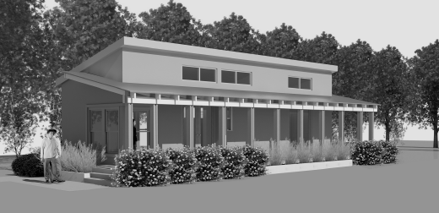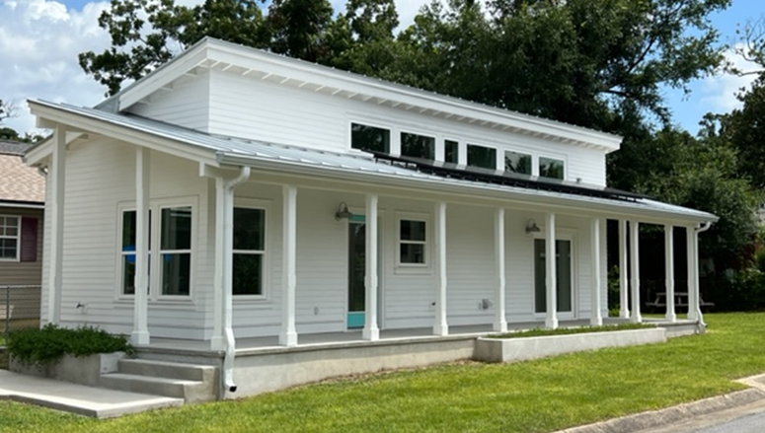
Concept Home Actual Home
The Authority is grateful for the opportunity to partner with PSC on this Urban Infill Project. The Authority offers services, including First Time Homebuyer Programs with Down Payment Assistance, the Urban Infill Program, and the ability to issue Single Family and Multi-Family Housing Bonds.
List of Participating Partners for 2300 North Tarragona Street, Pensacola,Florida 32501
