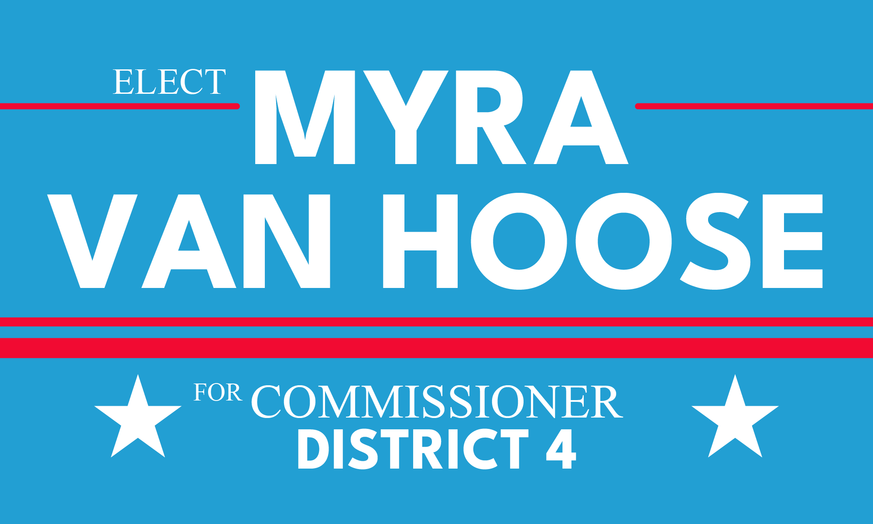

FOR IMMEDIATE RELEASE:
August 24, 2022

CONTACT:
Myra Van Hoose
850-261-8995
myravanhoose@gmail.com

Myra Van Hoose to take on Robert Bender in District 4 Commissioner’s Race in November

The final outcome of the race for County Commissioner in District 4 will be decided during the general election, which will take place on Tuesday November 8th, 2022.

Pensacola, FL — The race for the District 4 County Commission seat is still far from over. Democratic challenger Myra Van Hoose is currently running against Republican incumbent County Commissioner, Robert Bender, for the District 4 seat. Bender was announced the winner of the Republican primary election yesterday.

Van Hoose is a former CPA who started her career at the largest accounting firm in the world, working primarily with national leaders in healthcare and small business. She has since had her own practice and moved into non-profit management. Van Hoose has led groups for advocacy work in the arts, in politics, and with gender and racial equity issues.

“I understand the struggles of business owners while balancing the need for government assistance with infrastructure and social issues. I will use my professional skill set to create and work with a budget task force to eliminate county waste and use our resources more efficiently, prioritizing projects for the good of the community rather than from single commissioner slush funds,” Van Hoose states on her website.

Van Hoose has currently raised over $27,000 and is enjoying broad-based community support.

###

To learn more, visit www.myravanhoose.com

