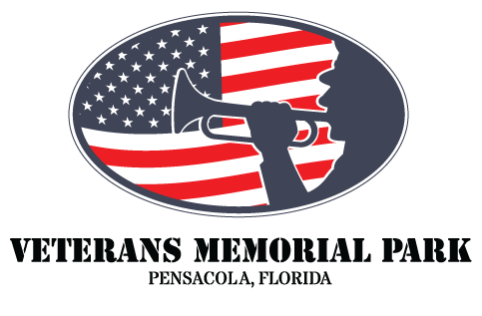
VETERANS DAY CELEBRATIONS TO INCLUDE OBSERVATION OF THE 30TH ANNIVERSARY OF THE WALL SOUTH AND A CEREMONY FEATURING HOLLYWOOD ACTOR AND VIETNAM VETERAN CAPT. DALE DYE, USMC (RET)
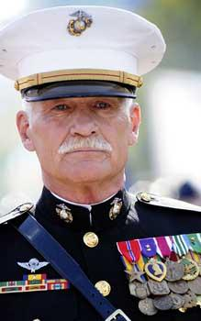
PENSACOLA, Fla., October 5, 2022 - The Board of Directors of Pensacola’s Veterans Memorial Park invite the community to join us at the park on Veterans Day, Friday, November 11th with the official ceremony to commence at 11 a.m. with the presentation of Colors to celebrate the lives and the contributions of our nation’s veterans. Prior to the ceremony at the public can enjoy visiting exhibitor booths and displays as well as food trucks starting at 9 a.m. The ceremony will feature musical performances by The Pensacola Civic Band, The Pensacola Opera Singers, and the Blue Anchor Belles. The newest monument at Veterans Memorial Park, “My Hero, My Friend,” will also be unveiled at the event. The monument, sculpted by artist Susan Norris, is a tribute to America’s war dogs and the significant role that they have played in protecting service members in so many of America’s conflicts. Keynote speaker will be Hollywood actor USMC (Ret) Capt. Dale Dye. Dye, a highly decorated veteran of the Vietnam War, will share some of his personal stories about his three tours of duty in Vietnam as well as speak to the honor and respect that America’s veterans have earned.
After retiring from the Marine Corps, Dye founded Warriors, Inc., a technical advisory company specializing in portraying realistic military action in Hollywood films with venerable Directors such as Oliver Stone and Steven Spielberg. He is best known for his military and technical expertise that he has offered to movies and television programs, including the HBO miniseries Band of Brothers and The Pacific. Prior to the production of the movie Platoon, Dye put the principal actors—including Charlie Sheen, Willem Dafoe, Johnny Depp, and Forest Whitaker—through an immersive 30-day military-style training regimen. Dye has acted in, written scripts for or directed many television and film productions. His more familiar credits include Platoon, Saving Private Ryan, Forrest Gump, Band of Brothers, Mission Impossible, and The Pacific.
Leading up to the Veterans Day ceremonies on November 11th, there will also be a number of activities to celebrate the 30th anniversary of the dedication of The Wall South in Pensacola, the nation’s first replica of the Vietnam Veterans Memorial. In partnership with WSRE Public Television, Veterans Memorial Park will host “The Reading of the Names.” The 58,318 names engraved on the granite panels will be read aloud at the apex of The Wall South by community members, students, veterans and active duty personnel. This solemn process, which will begin on Saturday, November 5th, will continue daily from 9 a.m. to 6 p.m. until Thursday, November 10 and will require over 1,200 volunteers. The last page of names, reflecting the last casualties of the Vietnam War, will be read at the Veterans Day ceremony by three local Vietnam Veterans. More information to participate in the reading of the names will be sent out to area media next week, including a link to sign up at https://www.veteransmemorialparkpensacola.org
Another special event planned is a gallery showing of photographs taken by Vietnam veteran Art Giberson, a Navy photographer who served during Vietnam and who captured the images of the construction and dedication of the The Wall South. Giberson’s black and white photographs will be on display at Pensacola State College’s Anna Lamar Switzer art gallery. The exhibit will be open to the public and can be viewed Monday-Friday from 8 a.m. – 4 p.m. starting November 7th through December 16.
“Our Veterans Day ceremony is an important opportunity for the local community to come together to thank and honor our veterans for their service and sacrifice,” said Veterans Memorial Park Foundation Board President Paul Entrekin. “This year the ceremonies will be even more special as we celebrate the 30th anniversary of The Wall South, the monument that established Veterans Memorial Park. We are also proud to welcome to our community Capt. Dale Dye, who himself is a Vietnam veteran and will share some of his experiences at our Veterans Day ceremony as our keynote speaker.”

###
About Veterans Memorial Park: For over 30 years, Veterans Memorial Park of Pensacola has been a place of healing, remembrance, learning and celebration of the lives and service of America’s fallen. The park, which hosts 12 monuments to every war and conflict that the United States has undertaken, is located in downtown Pensacola at 200 South 10th Avenue, facing the spectacular views of Pensacola Bay.
MEDIA CONTACT: Jill Hubbs (850) 572-2055
Niels Anderson (850) 477-2475

