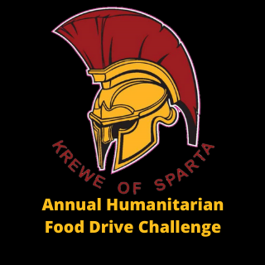

Contact:
DeDe Flounlacker, Executive Director, Manna
dede@mannahelps.org | (850) 432-2053

FOR IMMEDIATE RELEASE

All Krewe Food Drive Weigh-in Day at Manna Food Bank slated for Feb. 5

Pensacola, FL (January 30, 2023) – The Krewe of Sparta’s 12th Annual All Krewe Humanitarian Award Food Drive Challenge will culminate in a weigh-in day held at Manna Food Bank on Sunday, February 5, from Noon to 4pm. Several Pensacola Mardi Gras krewes have been collecting food donations for months to compete in the challenge. The food drive benefits the hungry in Escambia and Santa Rosa counties served by Manna Food Bank.

“The Pensacola Mardi Gras community is not just about the parties and parades,” said Jimmy Hendrix of Krewe of Sparta and Pensacola Mardi Gras’ 2020 King Priscus. “Krewes are dedicated to helping our community and making a difference, and this food drive is one way Krewe of Sparta and other krewes give back.”

As in years past, points are assigned as food is weighed-in from each krewe, and krewes with the most points win the challenge. Double points will be awarded for food items Manna needs most: canned fruit in 100% juice (20 oz. or less), canned vegetables (16 oz. or less), and oatmeal (boxes of individual packets). Double points items must be pre-sorted prior to drop-off at Manna.

“The healthy food that Manna receives from Krewe of Sparta’s food drive is critical for us, because food donations drop this time of year,” said Manna Executive Director DeDe Flounlacker. “The krewes ensure that the giving season continues in to late winter/early spring so that thousands of hungry children, senior citizens, veterans, families, and individuals in need are fed.”

Winners of the food drive challenge will be named in three categories: Small Krewe Division (50 members or fewer), Large Krewe Division (51-100 members), and Mega Krewe Division (101 members or more). Each division will be awarded a first place trophy with recognition given for second and third places, and winners will be announced at the Pensacola Mardi Gras Fat Tuesday Priscus celebration on Mardi Gras night.

For more information about Krewe of Sparta’s All Krewe Humanitarian Award Food Drive Challenge, please visit www.mannahelps.org/events/all-krewe-food-drive-challenge/.

###

About Manna
Manna’s mission is to offer emergency food assistance, service the food-related needs of vulnerable populations, and engage the entire community in the fight against hunger. A local grassroots organization with no national affiliation or government funding, Manna provided food to 69,095 people last year. Manna operates an emergency food distribution pantry and 17 specialty programs with 22 community partners in Escambia and Santa Rosa counties.

