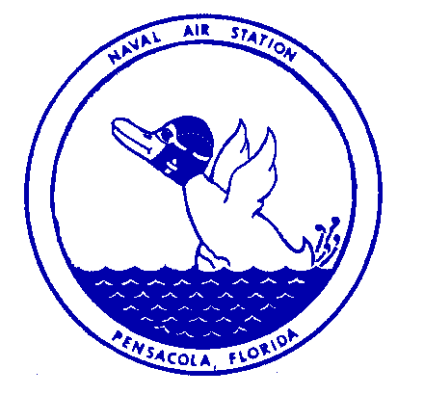Naval Air Station Ph: (850) 452-4436
Public Affairs Office
Pensacola, Florida DSN: 459-4436

PRESS RELEASE

FOR IMMEDIATE RELEASE Feb. 1, 2023

Navy to Conduct Force Protection Exercise Feb. 6 - 17

NAS PENSACOLA, Fla. – Naval Air Station (NAS) Pensacola will participate in an annual anti-terrorism force protection exercise Feb. 6 - 17.

Exercise Citadel Shield-Solid Curtain 2023 is conducted by Commander, U.S. Fleet Forces
Command and Commander, Navy Installations Command on all Navy installations in the
continental U.S.

The exercise is designed to enhance the readiness of Navy security forces and ensure seamless
interoperability among the commands, other services and agency partners.

Exercise CS-SC23 is not in response to any specific threat, but is a regularly scheduled exercise.
Measures have been taken to minimize disruptions within local communities and to normal base
operations, but there may be times when the exercise causes increased traffic around bases or delays in base access. Area residents may also see or hear security activities associated with the exercise.

Advanced coordination has taken place with local law enforcement and first responders.
For information about potential impacts due to the exercise, please monitor the NAS Pensacola Facebook and Twitter sites.

For more information, contact NAS Pensacola Public Affairs at (850) 452-4436.

- End -

