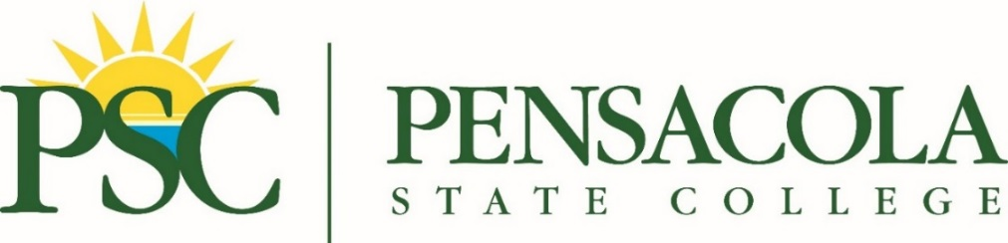

FOR IMMEDIATE RELEASE CONTACT: Sheila Nichols at 850-484-1428
March 13, 2023 or snichols@pensacolastate.edu
Pensacola State College’s International Festival scheduled for April 15
Filipino pancit, African drummers, Polynesian Hula Dancing, Irish bagpipe tunes and a Japanese bonsai exhibit will be among the many offerings at the 2023 Pensacola State College International Festival.

Set for 11 a.m.-6 p.m. on Saturday, April 15, the festival will transform the College’s Pensacola campus into a bazaar of global foods, entertainment and merchandise.

“Japanese food, Middle Eastern food, Greek food, Polish food, Filipino food, Mexican food, Puerto Rican-inspired Caribbean food, Italian food – you name the culture and it will be represented here at our International Festival,” said Juanita Scott, festival co-chairman and PSC director of Staff and Professional Development.

Larry Watson Jr. will headline the entertainment. The New School Motown-inspired singer will perform at 3 p.m. on the festival’s main stage. The MyxTape band will perform pop favorites and Filipino music in Tagalog.

“We’ll also have belly dancing from the Middle East, McGuire’s Irish Pub Pipe Band, Italian folk dancing, the Soulful Movement dancers, the Emerald Coast Okinawan drummers, and Japanese Miyabi dancers, just to name a few,” Scott said, adding the Pensacola Children’s Chorus Ambassadors Choir and Pensacola Children’s Theater Company also will perform.

So far, more than 30 vendors will have booths offering everything from natural skincare products to Name on Rice Jewelry to a 360 International photo booth.

Kathy Van Dyck, the festival chairwoman and PSC Humanities and Social Sciences Assistant Department head, noted that sponsors, vendors, performers and exhibitors are still needed.

She added the family-friendly event has something for everyone, including:
● A Children’s Village with activities such as face painting, a petting zoo, books, and educational resources vendors.

● Military Lounge with information on Pensacola State College programs and community resources available to active-duty service members, veterans and their dependents.

● Health and Wellness Lounge with information on the well-being of the mind, body and soul.

“At the entrance to the festival, we’re even providing International Festival Guest Passports to help guide visitors to the different continents,” Van Dyck said. “Attendees will be encouraged to get their passports stamped at each stop.”

Scott said that Pensacola State workforce programs ─ Carpentry, Welding, Cosmetology and Massage Therapy – will be showcased at the festival, adding representatives will be on hand to answer questions about enrolling in PSC.

As part of the International Festival, WSRE PBS will host the PSC Spanish Film Festival ─ screenings of five films from the Pragda Spanish Film Club series. The movies will be shown on the big screen in the Jean and Paul Amos Performance Studio starting at 10 a.m. Admission is free.

The films and showtimes are:
● “Cacu: A Change for Life” by director Marvin Del Cid at 10 a.m.
● “In the Heights” by Jon M. Chu at 11:30 a.m.
● “Even the Rain” by Icíar Bollaín at 2:15 p.m.
● “My Name is Gennet” by Miguel Angel Tobias at 4:15 p.m.
● “The Queen of Spain” by Fernando Trueba at 6 p.m.

The film festival was partly funded by a Spanish Film Club grant awarded to the College. The films were selected from the Spanish Film Club series made possible with the support of Pragda, SPAIN arts & culture, and the Secretary of State for Culture of Spain.

Scott said plans include making the festival an annual event - eventually a two- or three-day affair.

“We want to incorporate more entertainment, exhibits, and vendors to expand the learning opportunities for the community,” Scott noted. “As the festival grows, the College hopes to attract more sponsors who will create scholarships for students in the future.”

For more information, visit www.pensacolastate.edu/international-festival/.

Breakout box
The 2023 Pensacola State College International Festival
When: 11 a.m.-6 p.m. Saturday, April 15
Where: PSC’s Pensacola campus, 1000 College Blvd
Entertainers include the African American Soulful Movement Dancers, Chinese dragon dancers, Greek dancers, Pensacola Children’s Chorus Ambassadors Choir, Pensacola Children’s Theater Company, Filipino-American band, the MyxTape band, and more. A complete entertainment schedule will be posted at www.pensacolastate.edu/international-festival/ and on the festival grounds.
Fare includes German brats, Thai food, American-style barbecue, authentic soul food, and Mexican, Venezuelan and Chilean dishes, ice cream and other desserts.

Details: www.pensacolastate.edu/international-festival/

Photos:
Larry Watson Jr.jpg
Larry Watson Jr. will perform at the Pensacola State College International Festival set for April 15. The New School Motown-inspired singer will perform at 3 p.m. on the festival's main stage.

McGuire’s Irish Pub Pipe Band.jpg, MyxTape band.jpg, Soulful Movement.jpg

McGuire’s Irish Pub Pipe Band, the MyxTape band and Soulful Movement dancers are among the entertainers scheduled to perform on April 15 at the Pensacola State College International Festival.

