Become a Pensacola Beach Junior Lifeguard this Summer
Published May 12, 2023
The Pensacola Beach Junior Lifeguard program is seeking aspiring lifeguards between the ages of 13 and 15 to join an exciting and challenging two-week training session this summer on Casino Beach.
A tryout for the Junior Lifeguard Program will take place Saturday, June 3 at 7:30 a.m. at Quietwater Beach. The tryout will consist of an approximately 400-yard open water swim in waist-deep water, followed by a one-mile run on the sand. Applicants must attend the tryout to be considered for the program.
The program cost is $200 per person. Applicants accepted into the program must pay on the day of the tryout with a check or money order (credit cards or cash are not accepted). A parent must be present at the tryout.
During the program, junior lifeguards will learn about ocean rescue and medical care, participate in rescue drills, shadow the Pensacola Beach Lifeguards and enjoy beach recreation time.
There will be two program options for applicants accepted into the Junior Lifeguard Program, running from 9 a.m. to 3:30 p.m. Monday-Friday for two weeks each:
- Session one: June 19-30
- Session two: July 17-28
Click here for more information or email the Pensacola Beach Lifeguards at Lifeguards@MyEscambia.com.
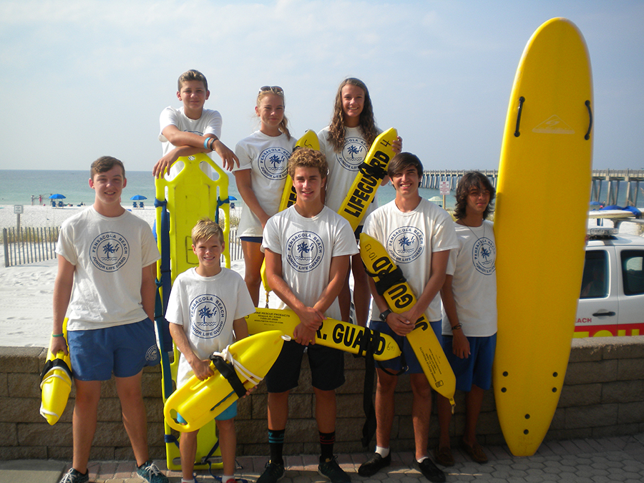
A group of junior lifeguards at Pensacola Beach in 2022

