Hosting An Event With Us

The Yellowknife Chamber of Commerce offers 4 different programs to help you connect and share information with members of the Yellowknife business community.

We’ll handle the details, so you don’t have to! All our programs are fully customizable.

Email admin@ykchamber.com to get started.

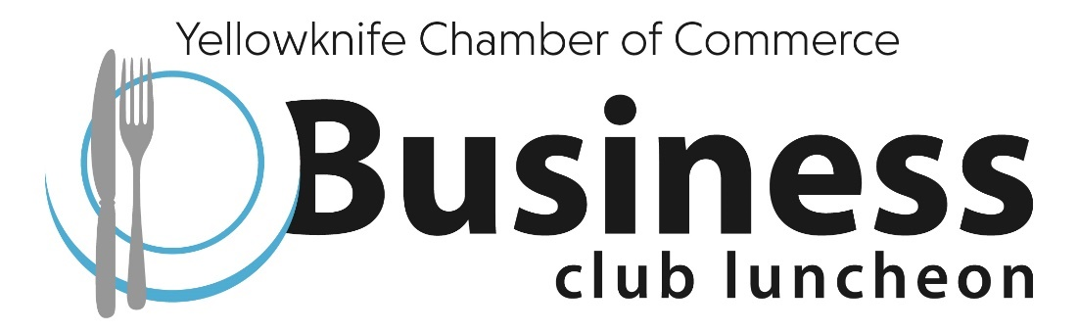

If you’re looking for an opportunity to solicit feedback (consultations) or share information with the Yellowknife business community in a more formal setting, consider hosting a Business Club Luncheon.

Previous events include:
- Mineral Report Release with GNWT
- Small Business Innovation Program Funding with Innovative Solutions Canada
- Yellowknife City Gold Project Update with TerraX Minerals and Investors Group
- Interest Rate Update with Bank of Canada
- Consultations For The Manufacturing Strategy for the NWT with the GNWT
- Economic Diversification Through Arts & Culture with Driving Force
- Mayor’s State Of The City Address with City of Yellowknife

These events are typically held between 12:00pm and 1:30pm and you can expect 40+ attendees.

The Details:
- We charge $2500 + GST which includes venue rental costs and AV equipment rentals
- To attract a larger audience, we encourage you to sponsor lunch for all guests. Otherwise, we charge $30/person to cover the cost of lunch
- We have event liability insurance
- You are required to provide a description of your presentation (100-200 words) that we’ll use to market the event
- We will promote the event using our e-blast service, website, social media and personalized invitations. We encourage you to distribute the invitation to clients, partners, and special guests
- We will handle registration, coordinate ticket sales, and greet guests when they arrive
- We will coordinate all event logistics – venue booking, AV, room set-up, food, décor, etc.
- You are required to bring your presentation on a USB
- The Yellowknife Chamber President or designate will provide an introduction and welcoming remarks
- We encourage you to bring promotional material, including signage, brochures, swag, etc.

Typical Business Club Luncheon Event Order:
11:30am – Doors Open
12:00pm – Opening Remarks from Yellowknife Chamber representative
12:30pm – Yellowknife Chamber representative will introduce Guest Speaker
12:30pm – Guest Presentation + Q&A
1:30pm – Closing Remarks from Yellowknife Chamber representative

If you’re looking for an opportunity to share your expertise by doing a presentation to an engaged audience in an informal conversational setting, consider hosting a Lunch & Learn.

Previous events include:
- For Employers: Recent Changes in Workplace Law That You Need To Know with Lawson Lundell
- Social Media and Content Marketing with With Media
- Hiring Foreign Workers with McLennan Ross
- Doing Business With The Government of Canada with the Office of SMEs
- Debt Collection For Businesses with McLennan Ross
- Protecting Your New Technology and Inventions with Field Law
- #MeToo In The Workplace with Dragon Toner Law Office

These events are typically held between 12:00pm and 1:00pm and take place in our boardroom. You can expect 10-20 attendees.

The Details:
- We charge $500 + GST which includes lunch for up to 20 attendees
- We have event liability insurance
- You are required to provide a description of your presentation (100-200 words) that we’ll use to market the event
- We will promote the event using our e-blast service, website, social media and personalized invitations. We encourage you to distribute the invitation to clients, partners and special guests
- We will handle registrations and greet guests when they arrive
- We will coordinate all event logistics – AV, room set-up, food, etc.
- You are required to bring your presentation on a USB
- We encourage you to bring any brochures or handouts that you’d like to provide attendees
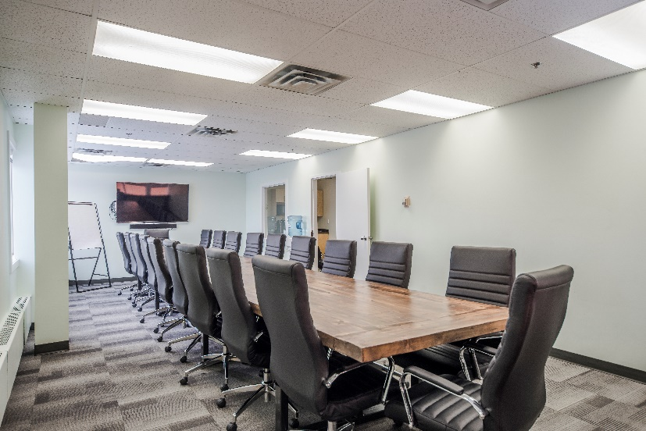

If you’re looking for an opportunity to consult with Yellowknife businesses or share your expertise in a virtual setting, consider hosting an On Demand Webinar.

Previous events include:
- COVID-19 Workplace Health & Safety with WSCC
- Updates To Funding Programs with Arctic Energy Alliance
- Canada’s COVID-19 Economic Response Plan with Crowe MacKay LLP
- Content Centric Digital Transformation with RICOH
- Expanding Your Business During COVID-19 with the City of Yellowknife
- Instagram Marketing For Your Business with Kristen Au Marketing
- COVID-19 and Hiring Foreign Workers with IRCC
- Force Majeure with Field Law

This virtual event will take place over Zoom and a tech rehearsal is required the day before. You can typically expect 5-20 attendees, depending on the topic.

The Details:
- We charge $350 + GST which includes free registration for up to 100 attendees
- You are required to provide a description of your presentation (100-200 words) that we’ll use to market the event
- We will promote the event using our e-blast service, website, social media and personalized invitations. We encourage you to distribute the invitation to clients, partners and special guests
- We will coordinate registrations and ensure all participants have access to the Zoom meeting
- With your permission, we will record the session and make it available on our website
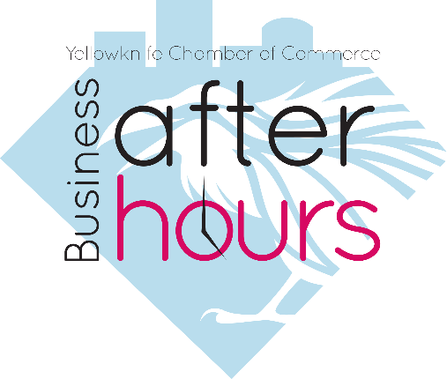

If you’re celebrating an anniversary, launching a new product or service, celebrating the recruitment or retirement of staff, or showcasing your new office / storefront, consider hosting a Business After Hours event.

Previous events include:
- Lodge showcase and activities for locals with Blachford Lake Lodge & Wilderness Resort
- Client Appreciation Open House with Stantec Architecture
- Directory Unveiling with Northwestel
- Grow Your China Business in NWT with Alipay with NWT Tourism
- Peru Portraits Reveal with Angela Gzowski Photography
- Open House – NWT BDIC
These events are typically held between 5:00pm to 7:00pm and take place at your business location. You can expect 30-50+ people.

The Details:
- We charge $1500 + GST, which includes catering for up to 50 guests
- Catering typically includes a selection of finger foods and appetizers that include vegetarian and gluten free options
- We’ll coordinate the catering logistics, but you must be available to receive the catering delivery and provide a space for set-up
- You are responsible for providing beverages
- If you choose to serve alcohol, we will provide you with the liquor license application and assist you with completing it
- You are responsible for providing a space for beverages to be served. If needed, we will provide bar tending services
- We will promote the event using our e-blast service, website, social media and personalized invitations. We encourage you to distribute the invitation to clients, partners and special guests
- We will coordinate RSVPs and provide you with a full list of attendees
- You must provide a registration table at the entrance of your venue. We will greet guests and track attendance to ensure you are in compliance with occupancy load requirements
- The Yellowknife Chamber President or designate will provide an introduction and welcoming remarks
- We will provide assistance with clean-up and tear down
- Door prizes are optional, but recommended

