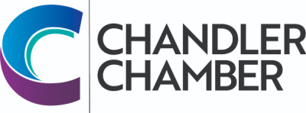

2023 COMMUNITY AWARDS NOMINATION FORM FOR
BUSINESS DIVERSITY
The Business Diversity Award recognizes an individual or business that is a role model for applying diversity as a means of achieving excellence in our community.

Note that a recipient cannot have received an award in the past 3 years.
The Selection Committee reserves the right to consider any nominee in another category.

To Qualify, Nominee Must:
- Be actively involved in the Chandler community
- Have created a significant difference in the promotion of diversity in Chandler
- Exhibit a high degree of willingness to help others
- Be located in the Chandler area
- Be a Chandler Chamber Member
- Have been in business in the Chandler area for at least two years

Please complete the form below to nominate an individual or business for the Business Diversity Award. Incomplete entries will not be considered. Completed nomination forms must be returned to the Chandler Chamber (101 W Commonwealth Ave, Chandler, AZ 85225) or emailed to Angie@chandlerchamber.com by Friday, April 7, 2023.

Please Print
Business Name:
Owner/Principal:
Business Address:
City/State/Zip:
Business Phone: Type of Business:
Type of Services or Products: ____ ______
Year Established: Years in Chandler:

Reasons for Recommendation: Please address each of the award criteria. List significant milestones, community and civic activities, awards, business and professional ethics, etc. (attach separate sheet, if necessary).
________________________________________________________________________________________________________________________________________________________________________________________________________________________________________________________________________________________________________________________________________________________________________

Nominated By: _______ Please print - name and business name (if affiliated with a business)
Address /City/Zip:
Phone: E-mail: ______

