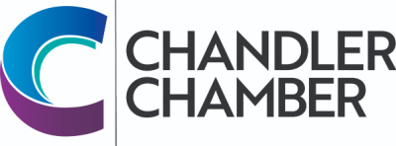
2023 COMMUNITY AWARDS NOMINATION FORM FOR
CHAMBER CUP, COMMUNITY CUP, JAMES R. SNEDIGAR PUBLIC SAFETY AWARDS
Please check the box for the award you are nominating an individual.
Note that a recipient cannot have received an award in the past 3 years.

The Selection Committee reserves the right to consider any nominee in another category.
AWARD:
Chamber Cup Community Cup James R. Snedigar Public Safety

Please print

Name of Nominee:
Address:
City/State/Zip:
Tel. Number:
*Please include reasons why you are nominating this business or individual. List significant milestones, community and civic activities, degree of nominee participation, functions fulfilled, innovations, etc.
_____________________________________________________________________________________________________________________________________________________________________________________________________________________________________________________________________________________________________________________________________________________________________________________________________________________________________________________________________________________________________________________________________________________________________________________________________________________________________________________________________________________________________________________________________________________________________________________________________________________________________________________________________
All nominations must include a letter of recommendation for the nomination to be considered.

Nominated By: Please print - name and business name (if affiliated with a business)
Address /City/Zip:
Phone: E-mail: _________________

