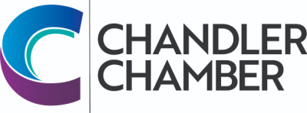
2024 COMMUNITY AWARDS NOMINATION FORM FOR
MICRO, SMALL, MEDIUM & LARGE BUSINESS OF THE YEAR

Please check the box of the award you are nominating for.
Note that a recipient cannot have received an award in the past 3 years.
The Selection Committee reserves the right to consider any nominee in another category.

AWARD:

  Micro Business of the Year (1-5 employees)   Small Business of the Year (6-50 employees)
  Medium Business of the Year (51-100 employees)   Large Business of the Year (101+ employees)

Please print

Business Name: _______________________________________________
Owner/Principal: ________________________________________________
Business Address: _______________________________________________
City/State/Zip: ______________________________________________________
Business Phone: _______________________________________________
Type of Business:
Type of Services or Products:
Year Established: Years in Chandler: ____________
No. Employees: Annual Sales in $ (if known):
*Please include reasons why you are nominating this business or individual. List significant milestones, community and civic activities, awards, business and professional ethics, etc.
___________________________________________________________________________________________________________________________________________________________________________________________________________________________________________________________________________________________________________________________________________________________________________________________________________________________________________________________________________________________________________________________________________________________________________________________________________________
* All nominations must include a letter of recommendation for the nomination to be considered.

Nominated By: Please print - name and business name (if affiliated with a business)

Address /City/Zip:

Phone: E-mail:

