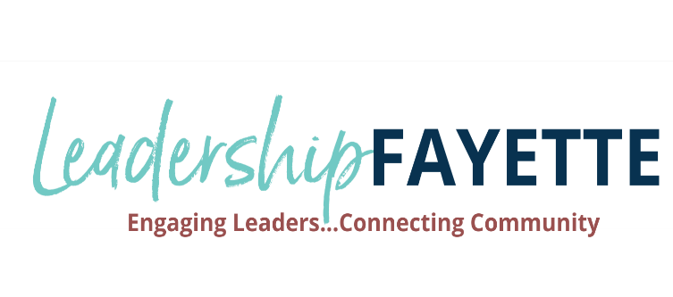
Important Dates to Remember:

Personal & Business Information
April 26, 2023:
June 9, 2023:
June 5-14, 2023:
June 14-16, 2023:
June 19-20, 2023:
July 21, 2023:
July 18, 2023:
August 14-15, 2023:
Applications available.
Application submission deadline (5 p.m.) Finalists contacted to schedule interviews Interviews
Announcement of LF Class of 2023
Tuition payment due
Class Introduction and & Alumni Reception
Mandatory Orientation/Leadership Retreat

Last Name First Name MI

Home Address City State Zip

Work Phone Number Cell Phone Number

Email Address Male Female

Business/Employer/Organization Name Job Title

Business/Employer/Organization Address City State Zip

Years living/working in Fayette County

Have you participated in a similar leadership program in another community? yes no

If yes, where/when?

Education

High School / City / State Years Attended

College / Technical School Years Attended/Degree

Graduate School/Professional Certifications Years Attended/Degree or Certification Received

Extracurricular Activities

Submit application via email Cereto@FayetteChamber.org or mail/drop off to Fayette Chamber of Commerce 600 W. Lanier Ave., Suite 205, Fayetteville, GA 30214



Employment History (List most current first.)
Employer Position Dates Job Title

Organizations & Activities (List in order of personal importance any civic, professional, religious, athletic, or social activities to which you belong or have belonged. Please briefly describe involvement or leadership roles held.)
Organization/Activity Dates Leadership Roles/Details

Honors, Awards & Recognition (List in order of personal importance any honors,

awards and recognition received.)
Honor/Award/Recognition Entity from Which Received Date

Why would you like to be a part of the Leadership Fayette’s Class of 2024 and why are you a good candidate? (May be submitted as separate document.)

Guidelines for Commitment:
Attendance is required so that attendees receive a meaningful experience from investment. Participants and their employers must be willing to commit the necessary time to fully participate in the program. To graduate, a participant may not miss more than one (1) day of class and must complete additional enrichment activities to make up any missed time. Tuition is non-refundable.

Applicant Commitment
If selected to participate in the Leadership Fayette Class of 2024, I will devote the time required to attend all events and sessions within the program. I understand my attendance and preparedness are mandatory and that if I fail to meet the obligations of the program, I will be disqualified from graduating from the program.

If selected to participate in the Leadership Fayette Class of 2024, I will arrange for payment of my tuition within three
(3) weeks of notification.

Participant Signature Date

Please complete the following depending upon employment status:

Employer Commitment (to be completed by applicant’s employer, if applicable)
I recommend the applicant for the 2024 Leadership Fayette Program. As his/her employer, I agree to make the time available for full participation in all scheduled class sessions and activities and that all sessions can be attended without penalty. I also understand if they are withdrawn from the program due to absences, tuition is non-refundable.

Employer Signature Date

Printed Name Business/Company/Organization Email Address

