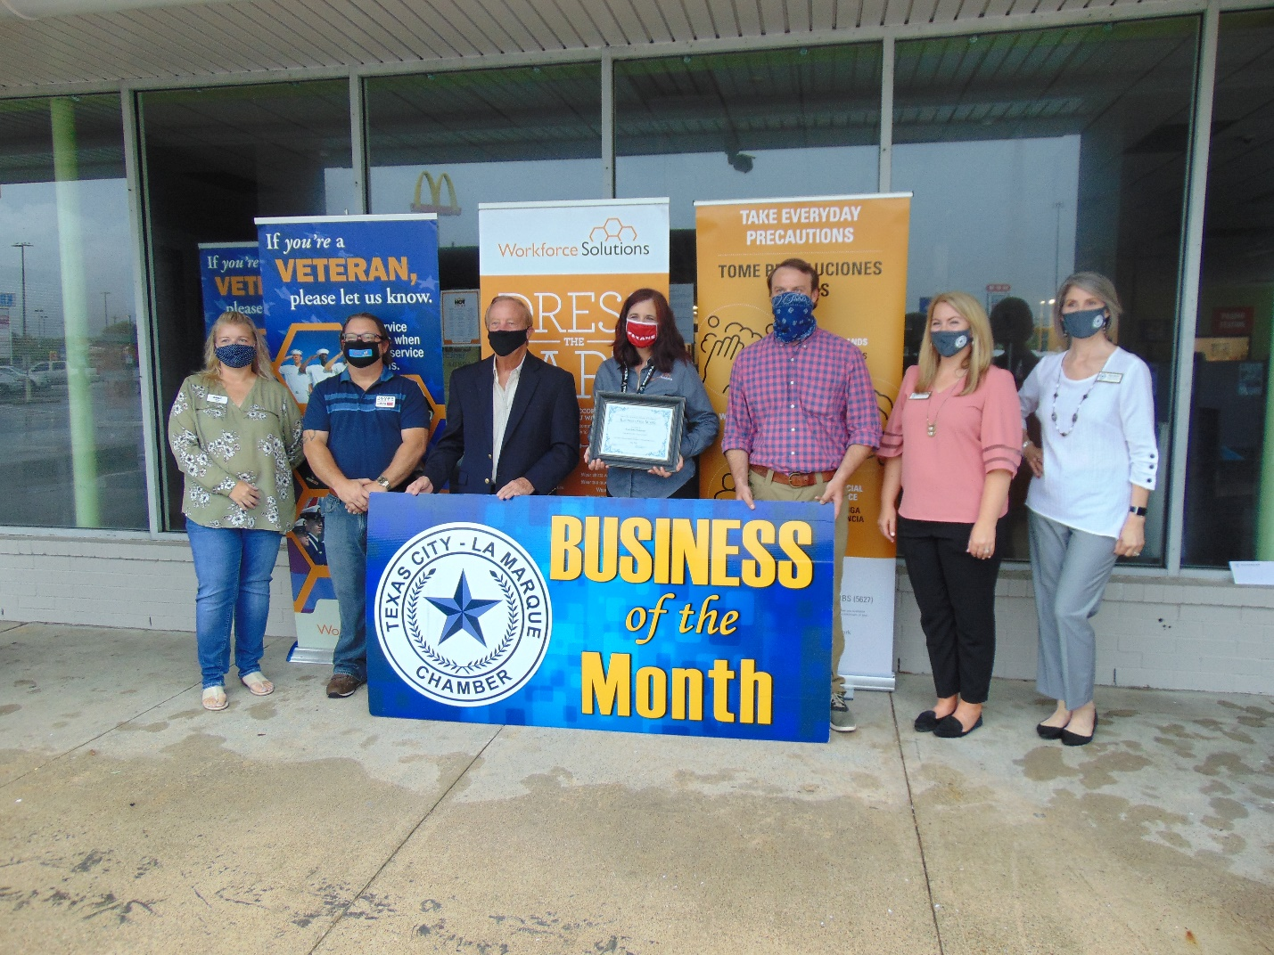
Workforce Solutions
3549 Palmer Highway
Texas City, TX 77590
(409) 949-9055
Jennifer Bridgeford, Career Office Manager
Workforce Solutions – Texas City
3549 Palmer Highway, Texas City, TX 77590
TEL 409-949-9055 EXT. 3001 FA X 409-949-9035
jennifer.bridgeford@wrksolutions.com
www.wrksolutions.com – Facebook Instagram LinkedIn Twitter YouTube
a proud partner of the American Job Center network

Work Force Solutions
The first Worksource office opened in 1997 at the Family Community Center on Texas Ave. In the early 2000’s we relocated to our current location in the old Academy building on Palmer Highway. We’ve had a satellite office in Clear Lake that served transitioning job seekers from the Aerospace Industry and one on Galveston Island to serve the community hard hit by Hurricane Ike in 2008. Currently, over 9,000 people walk the through doors of the Workforce Solutions office in Texas City per year seeking assistance to get a job, keep a job or get a better job.
The office is part of the Gulf Coast Workforce Board as its operating affiliate Workforce Solutions, the public workforce system in the 13-county Houston-Galveston region of Texas. We help employers meet their human resource needs and individuals build careers, so both can compete in the global economy.
The team of Workforce Professionals provides individualized service that helps employers find qualified applicants for specific jobs and develop custom solutions to strengthen their current workforce. We partner with the Texas Workforce Commission and other workforce boards in the largest job-matching database in the state - WorkInTexas.com. We offer job search and job matching assistance, career counseling and financial aid for education/training or work support.
They host the monthly Galveston County Workforce Partnership meeting on the last Tuesday of each month to connect community partners with each other and career office staff to provide 365-degree services to our local community. We actively support our local school districts, career training vendors and chambers of commerce.
They continue to provide virtual services with over 35 staff working remotely during the COVID-19 pandemic and engage with the community through our active Facebook page.

