Brandon Wade
GCWA General Manager/CEO

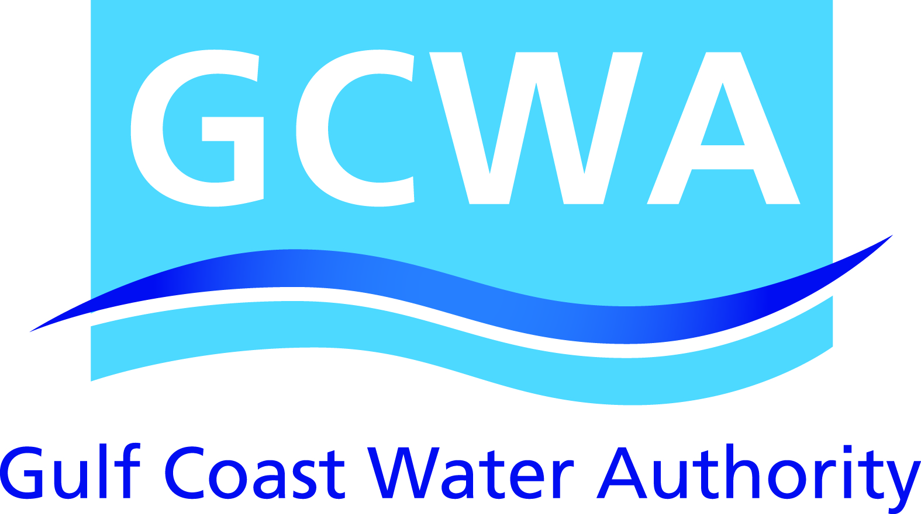
3630 FM 1765
Texas City, TX 77590
(409) 935-2438

Tell us a little about your background.
I’ve served as General Manager/CEO of the Gulf Coast Water Authority (GCWA) for a year after serving as Deputy General Manager. I have more than 35 years of municipal experience, including Pflugerville City Manager; Galveston Deputy City Manager, Director of Public Works and City Engineer; and Alvin Director of Community Development and City Engineer.

I have a Master of Public Administration degree from the University of Houston and a Bachelor of Science degree in civil engineering from Texas Tech University.

How would you describe what you do?
Our mission is to reliably deliver up to 200 million gallons of water a day to industrial, municipal and agricultural customers in Brazoria, Fort Bend and Galveston counties.

We draw water from the Brazos River Basin and maintain an extensive water delivery system that includes 315 miles of canals, 4 pump stations, 2 reservoirs totaling 12,000 acre-feet and 35 miles of pipelines.

Our major operations in Texas City include the following:
- Industrial pump station with 95 million-gallon daily capacity for Texas City industries
- Thomas Mackey Water Treatment Plant, which has a daily capacity of 57 million gallons and provides drinking water to most of Galveston County
- Administrative office

How has your business evolved over time?
Beginning with its legacy agricultural and industrial entities in the early 1900s, GCWA has evolved and grown to meet the ever-changing needs of the communities and businesses it serves.

In 1965, the Texas Legislature established GCWA as a water utility essential to the growth of communities, businesses and the petrochemical industry in our service area.

What are you working on now?
Water is a limited resource, but the need will continue to grow. We are focused on making sure that we can reliably deliver water to our customers now and in the future. We continue to identify new, long-term water resources and improve or replace aging infrastructure.

Read more about GCWA on our new website: www.gulfcoastwaterauthoritytx.gov

