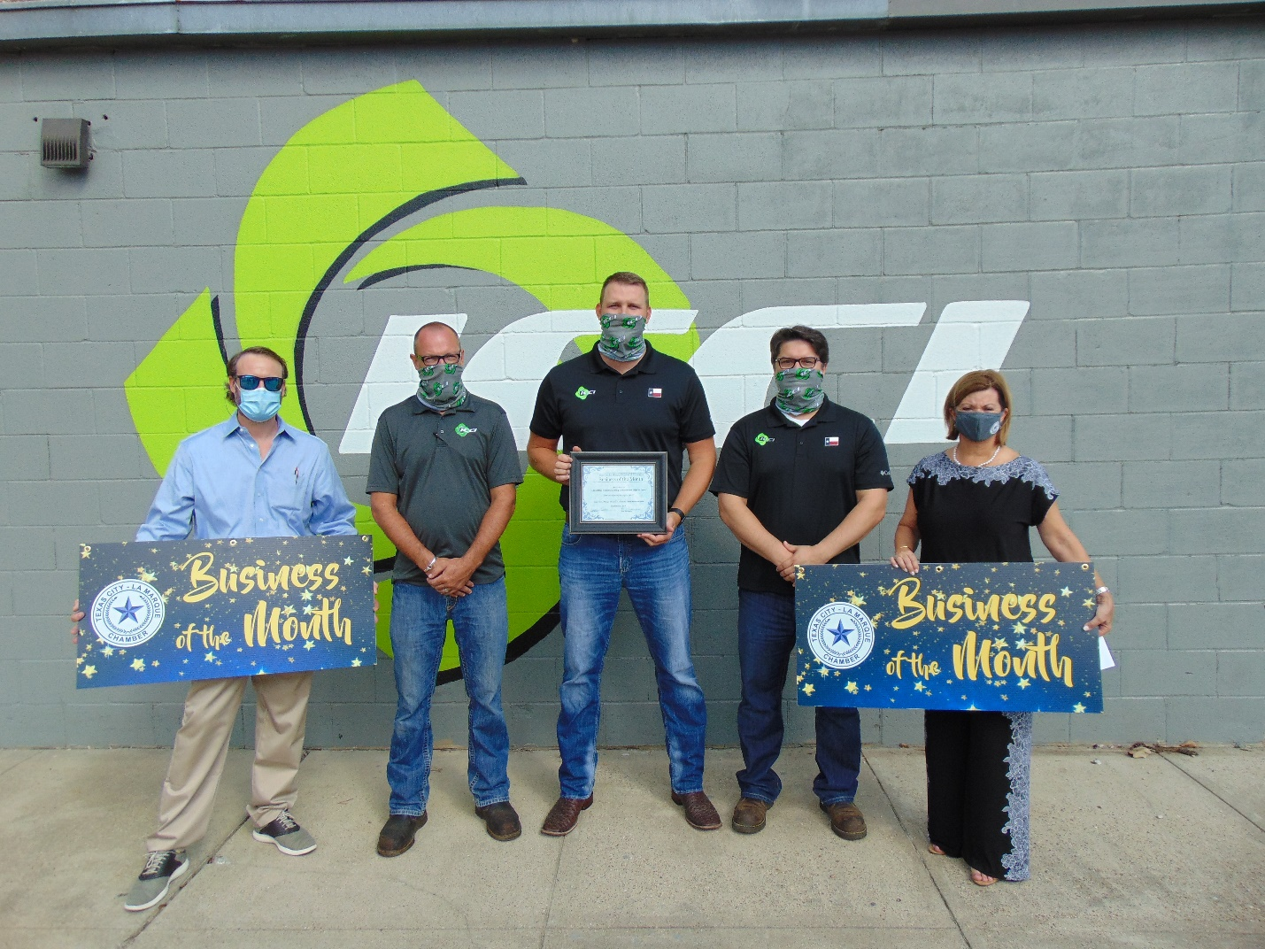
Industrial Commissioning Consultants International
(ICCI)
714 Hwy 3
La Marque, Texas 77568
(409) 797-4749 | 833 USE ICCI
Representatives

Steve Quinn, Chief Executive Officer

Bill Bogar, Chief Financial Officer
Joshua Phelps, Vice President of Operations
Thomas Keim,

Formed in 2002 by highly experienced industry veterans, ICCI is a specialist provider of comprehensive Pre-commissioning cleaning services for the new construction of industrial projects including power plants, LNG facilities, petroleum refineries, and petrochemical facilities. The company’s experience and focus on specialized Pre-commissioning cleaning services has led to numerous, proprietary methods and equipment developments.

ICCI’s proprietary, highly engineered equipment is designed for the specific purpose of efficiently cleaning each process system. Our equipment undergoes regular refinement, driven by a Pre-Commissioning project feedback loop supported by our internal systems and substantial knowledge base.
ICCI is based in La Marque, TX with a fleet of equipment able to mobilize anywhere in the world. All equipment can be mobilized by land, sea, or air if required.
Pre-Commissioning cleaning is what we do. ICCI’s sharp focus has led us to develop and deploy proprietary, field-proven equipment and methods. Our depth of experience has shown us the best ways to maximize efficiency, to deliver the results you want. Our track record makes it clear: ICCI Pre-Commissioning services achieve (and often exceed) specifications, on your schedule.
ICCI’s unique and powerful combination of deep experience, sharp focus, and high-performance equipment maximizes productivity, optimizes service execution, and delivers the highest value for your Pre-Commissioning budget.

Specialties
Precommissioning, Commissioning, Oil Flushing, Chemical Cleaning, Air Drying, Steam Blowing, Camera Inspection, Engineering, Air Blowing, Vacuum Dehydration , Oil Filtration, Line Drying, Hydrostatic Testing, and Equipment Rental

