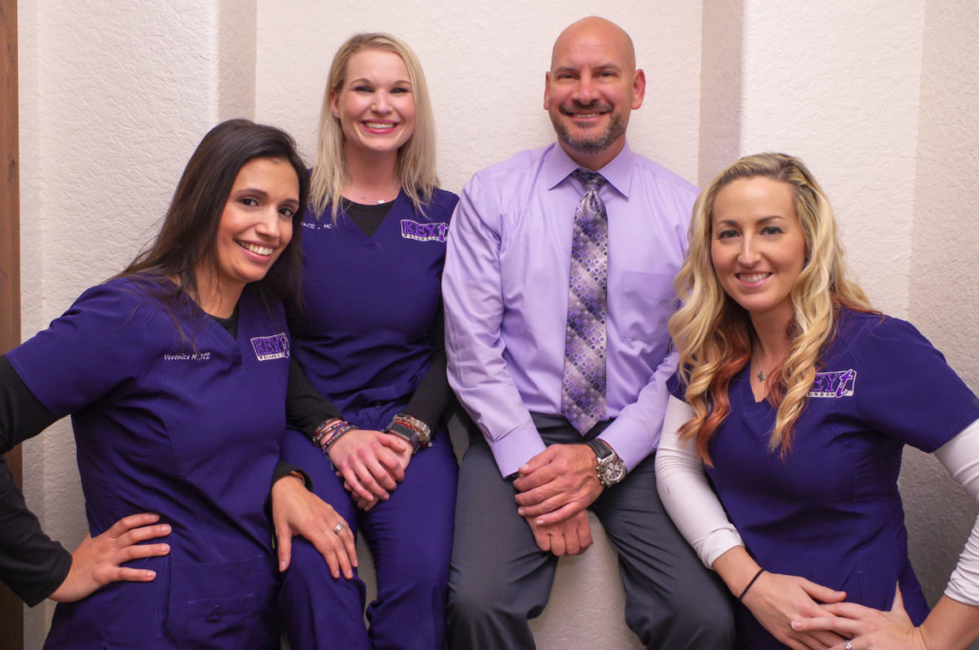

**Key T Wellness**

1621 FM 517 East-Suite B  
Dickinson, TX 77539  
(833) 539-8123

**Representative:** [John Bargerstock](javascript:repDetails(22741);), Clinical Director

We are a wellness clinic that was established in the summer of 2018 by myself, a Physician Assistant and product of Baylor College of Medicine and in practice now since 2002.  I am also a military veteran of 30 years, with a background in surgery, primary care medicine, now in Wellness/Anti-aging medicine for the last several years.  My medical director is also practicing in and from the area (Dr. James Jackson) who owns a stand-alone ER (***Emergicare***) and a graduate of Texas A&M and UTMB Galveston medical program.  Our patient AND employee centered organization is what makes us special:  Our *QRS* philosophy focuses on “**Q**uality employees,” “**R**esults driven care,” and “**S**uperior service.”

We specialize in various anti-aging/wellness medicine services that include:

* + Low T (Testosterone) Therapy -Men
  + Hormone Optimization – Women
  + Vitamin B12
  + Weight Loss
  + Botox and Fillers
  + Spider Vein Treatment
  + Skin Tag Removal
  + Body Composition Analysis

Key T Wellness is all about helping our patients *unlock their true potential*.  Each and every patient receives a comprehensive evaluation and is educated on a customized treatment plan best suited for their individual needs.  The “one-size-fits-all” approach is not the philosophy patients should expect and it’s certainly not what we offer. Every patient receives a personalized medical approach to their treatment plan.  Patients are all different, each requiring a “unique and customized” treatment plan for optimum results. This is what sets us apart from many of the other providers and wellness centers out there.

We were established in Aug 2018 in Dickinson, TX and are expanding our reaches to surrounding communities in 2020 and beyond.  We are increasing our personnel to meet the demand for our growing volume and anticipate further growth in 2020 to include multiple locations in the greater Houston area.

Becoming difference makers in the community by making illness an option, by focusing on wellness, and by donating our time/money for charitable causes. Joining multiple Rotary clubs and Chambers in the surrounding communities during our short existence.

Not only are we currently underway with the construction of our 2nd location in Pasadena, TX, but we are expanding our services to include more cutting edge services like Peptide therapy, other modalities for delivering HRT (for men/women), Expanding our Social Media platform with bringing GoDaddy onboard, as well as, working on other very exciting services (more to come on that) to the public.