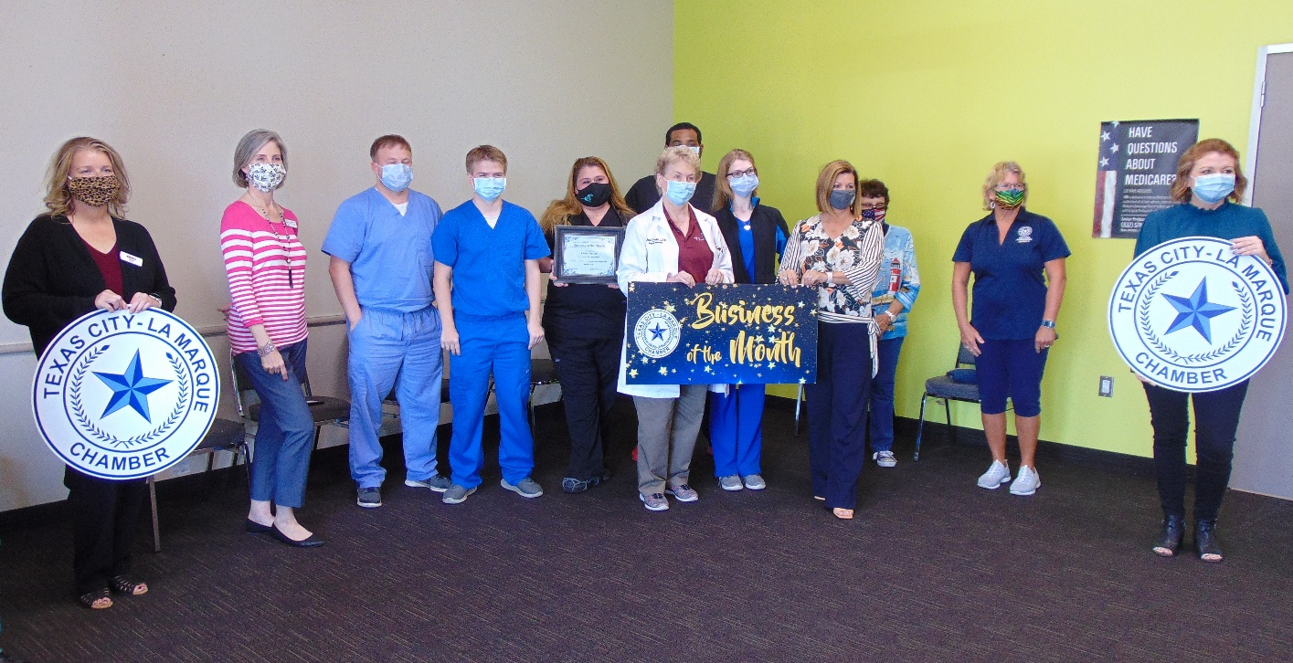
Family Practice
14025 Delany Rd.
La Marque, Texas, 77568
Dr. Janis Fowler-Gulde
www.familypracticepa.com

Coming to La Marque Crossing (the corner of I-45 and FM 1765) this Thanksgiving, Family Practice is opening a 5,000-squarefoot medical office focused on expanding healthcare access to every resident of La Marque and surrounding towns. The business’ experienced physician of 28 years has the knowledge and expertise to provide compassionate care at every level of clients’ healthcare journeys. Family Practice is proud to announce that the business will be the pioneers of Galveston County and beyond, separately engineering well and sick entrances and exits. Clients no longer will have to worry about the exposure of infectious diseases when they go to the doctor for a routine visit or chronic care management. All the sick areas will have dedicated staff, air conditioning and isolation protocols, while the non-infectious sections will allow for expedited check-in and check-out via technology. Family Practice will offer expanded services such as IV hydration therapy, sports physicals for youth and automated immunizations via a direct vaccine distributor’s partnership. Through a partnership with the DEXA scan, the facility will have an on-site bone density and obesity scanner. The DEXA will allow the weight loss program to have actual body composition imaging to mirror the diet and medication program. The bone density scanner will help the aging population with early diagnosis of bone disease. Family Practice will continue to offer home delivery of vitamins and supplements through a direct discount program. Most patients save 20 percent to 30 percent off the retail price for essential life vitamins that are not currently in people’s modern diet. For the chronic care and elderly population, Family Practice has several relationships with home health agencies that report directly back to the clinic to maintain care continuity. The staff is dedicated to their chronic care patients, including diabetes management, hypertension, hyperlipidemia and many other chronic conditions. The facility uses the latest drug and treatment programs’ research and tools to ensure patients can stay healthy with the least medications possible.

Currently, Family Practice is operating in a temporary location in Gulfway Plaza, located on Delaney Road in La Marque. The business can handle testing for COVID-19 and still see patients without delay, but look forward to the new location’s convenience of independent entrance. Schedule a visit by calling the office at 409- 655-2770.

Temporary location
14025 Delany Rd.
La Marque, Texas, 77568

Future location
6608 Gulf Freeway, Suite 100

La Marque, Texas, 77568

