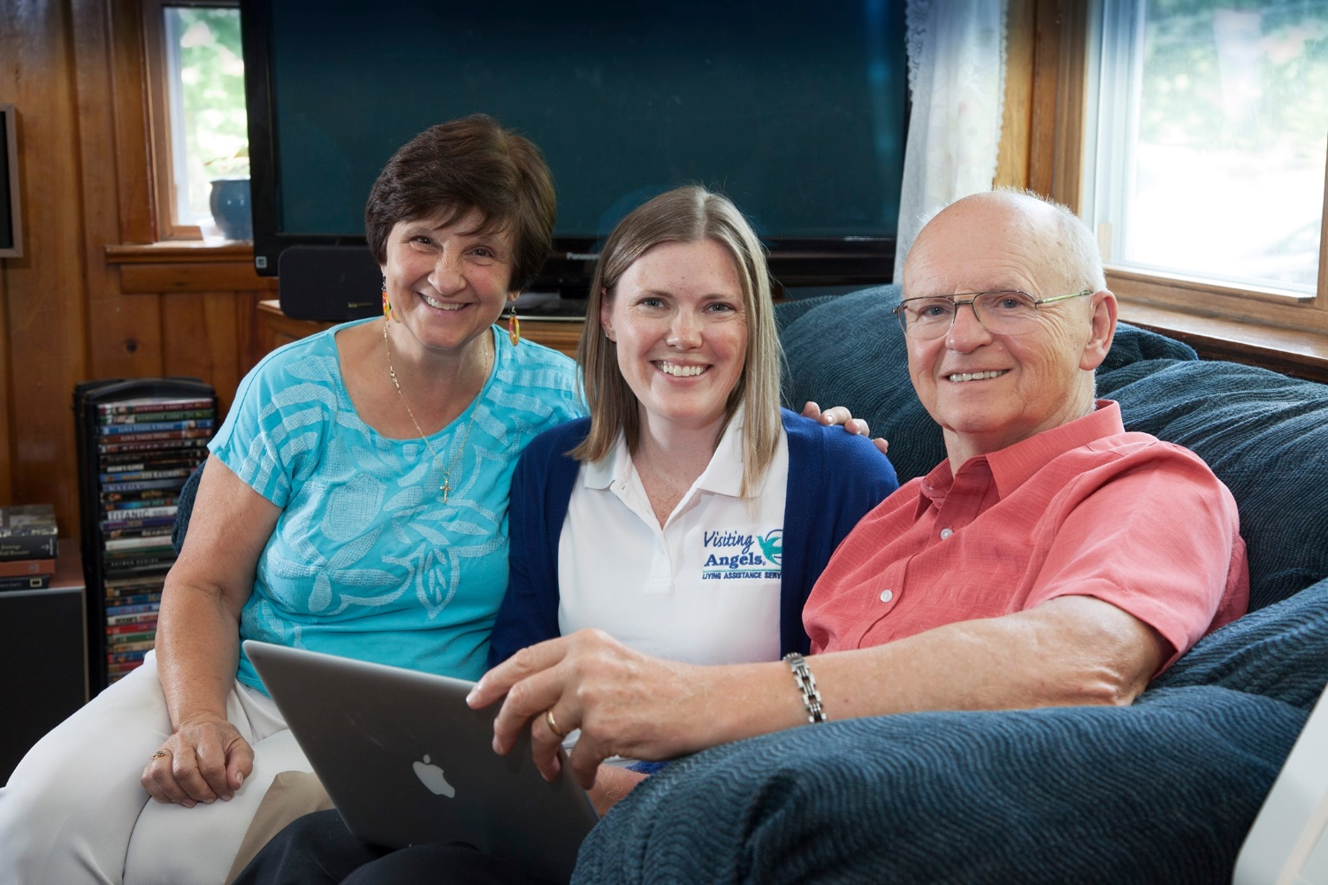
Visiting Angels
10000 Emmett F Lowry Expy
Suite 4000 - Unit 200D #8
Texas City, TX 77591
409-489-4501
jbasciano@visitingangels.com
Jennifer Basciano- Owner

Tell us a little about your company’s background.

Visiting Angels has been providing compassionate elder care services to families across the United States. Our network of elder care franchised agencies is committed to providing families with the best possible in-home care services. Our commitment to you is simple: We will help your loved one continue to live at home, and we’ll help you find peace of mind. Visiting Angels in Texas City has been serving Galveston County for 2 years. I bought the business to enable the elderly to remain independent in their homes. I wanted to give them an option besides going to a nursing home.

How would you summarize what you do?
Visiting Angels is licensed by the state of Texas to provide non-medical in-home care and help with activities like: bathing, dressing, medication reminders, light housekeeping, laundry, errands, and meal planning and preparation. At Visiting Angels, we understand you want top quality senior home care services for your loved one. You're searching for a qualified, professional elder care provider who will treat your family member with respect and dignity. We can help you find the senior home care provider that meets all your needs. Our senior home care providers are professionals with the training and skills you have been searching for. We’ll match you with a senior home care provider who will care for all your loved one’s health and well-being needs.

How has your business evolved over time?
My Visiting Angels agency was the first to service Galveston county. In 2 years we have grown to produce over $300k in sales and we work with clients from Alvin to Galveston island. Seniors throughout the area can get started with elderly care by contacting Visiting Angels Galveston and booking a no-cost consultation. Our knowledgeable care coordinator will meet with your loved one at home to discuss their needs. During your meeting you can get answers to all your care questions and help to create a customized plan to meet your loved one's needs. Our services are flexible so your loved one will be able to make changes over time if needed.

What are some of your proudest accomplishments?
My proudest accomplishment would be the over 100 clients we have served in 2 years. These are people who would have otherwise had to go to a nursing home if it were not for our help. Instead they aged peacefully in their home where they were most comfortable. I am also proud of our Google reviews and the many letters of recommendation we receive.

What are you working on now?
We are rapidly growing to service more clients and we are always hiring qualified caregivers.

Jennifer Basciano
Owner and Operator of Visiting Angels Galveston
Phone 409-489-4501
jbasciano@visitingangels.com
Please leave us a Review!
https://www.visitingangels.com/galveston/website-inquiry

