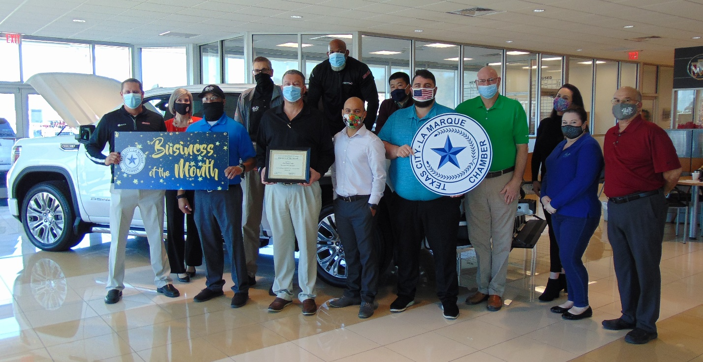
Gay Family Auto
3033 Gulf Freeway
Dickinson, TX 77539
(281) 337-2521
www.gayfamilyauto.com
sgay@gayfamilyauto.com
Owner: Shane Gay
Manager: Kevin Lardie

Gay Buick GMC and KIA has been in business since 1948. Carl and Marie Gay started out on HWY 3 as a Pontiac dealership. In 1966 they moved to the newly built Gulf Freeway. In 1970 they added GMC and in 2010 KIA. The business is now owned by the 3rd generation, Shane Gay and his wife Kate.
The dealership employs just under 100 people throughout the two dealerships which include sales, Service departments, Parts and Body Shop. General Manager Kevin Lardie has been there for 25 years and stresses the importance of the employees being involved in the community and taking care of their customers.
They believe the customer is king and customer satisfaction is the main goal. Stop by and see why it really is “The Best Place to Buy!” We have two locations that sit side by side on i45 South; our Buick and GMC building and the newly added KIA building. If you are looking for a new vehicle in Houston, Galveston County, Brazoria County or Harris County Gay Family Auto Group is ready to serve you. The Staff will treat you professionally, with respect, and honesty while giving you the best price possible on a new or preowned vehicle.

